sustaining emis operational savings
Participant Workbook

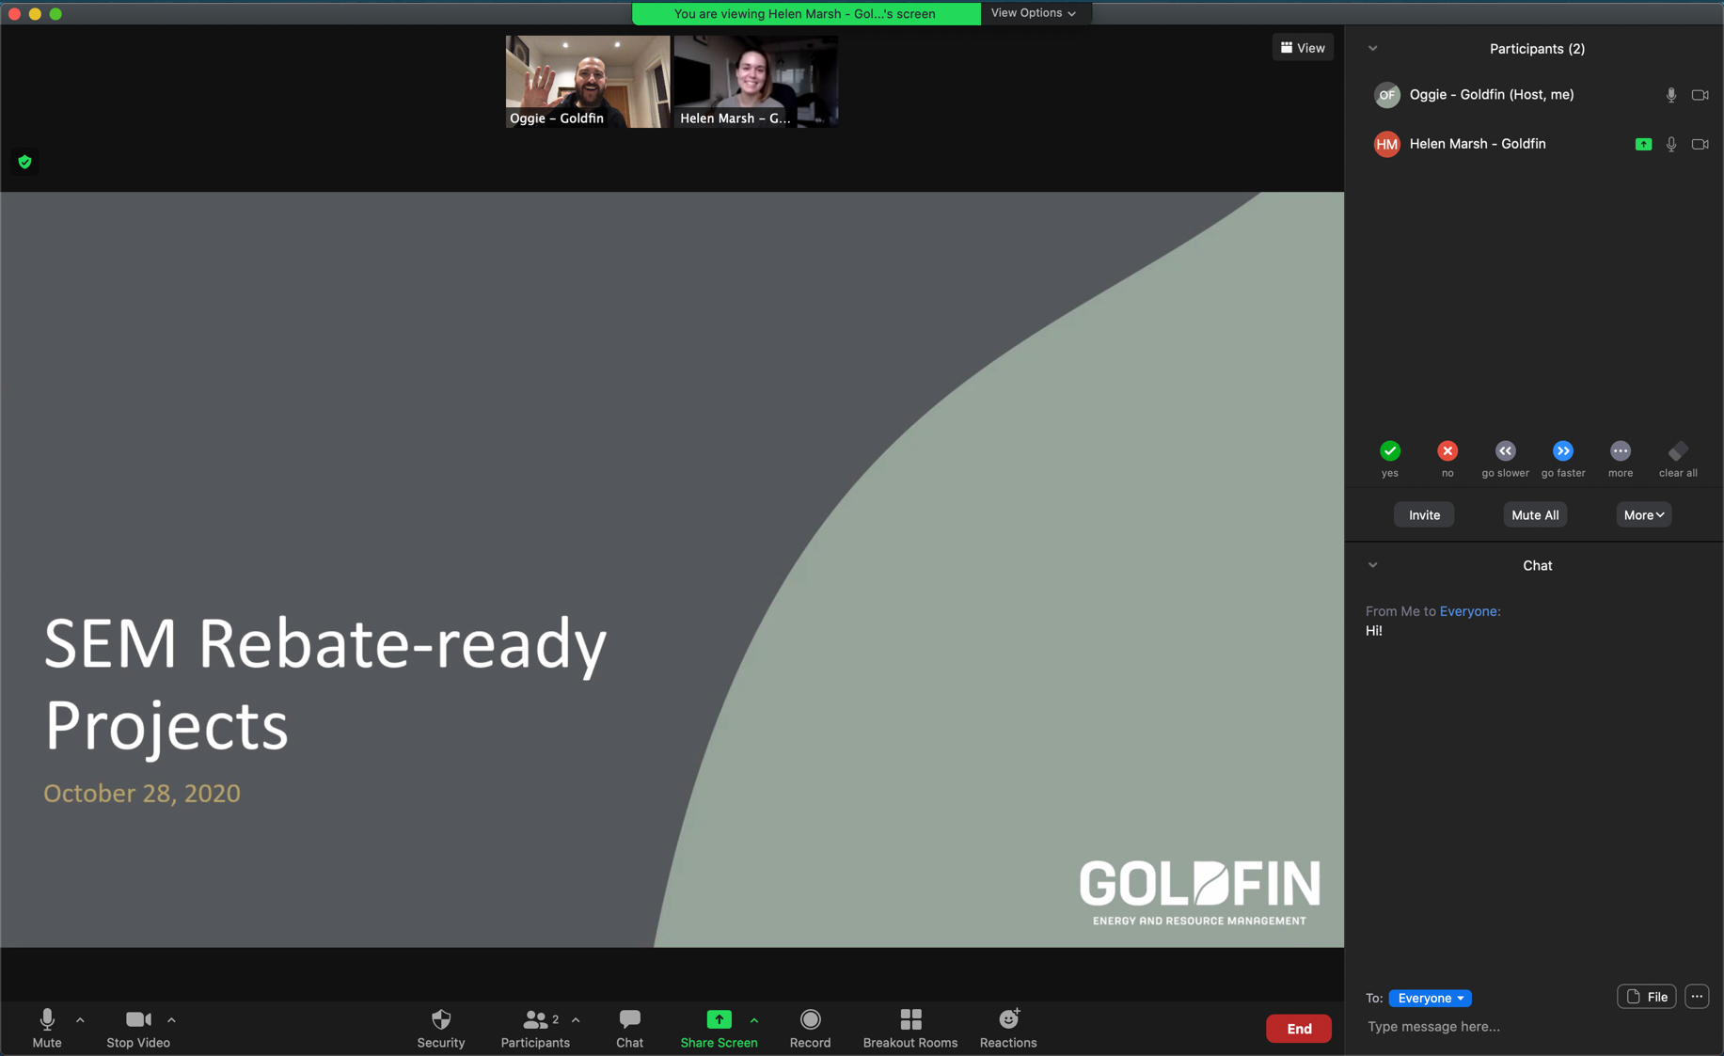

Many facilities benefit from energy performance improvements after the implementation of an energy management information system (EMIS) only to see them slip away soon thereafter. Without active strategies to maintain gains, equipment, people and priorities drift — and so do savings.

This workshop explores proven strategies to lock in energy savings by integrating EMIS processes into day-to-day operations.

In this workshop, Participants will:
- Learn how performance drift occurs and what is required to sustain operational savings
- Practice identifying common failure points and strategies to sustain savings using real-world examples
- Develop first steps toward a strategy to sustain operational savings for their own organization

This workshop is hosted via Microsoft Teams.
For instructions or troubleshooting, please
see the last page of this workbook.

Why savings degrade
Many industrial sites experience energy savings losses six to 18 months after EMIS installation or efficiency upgrades. The issue is not always technical; it is often behavioural or systemic.

Common causes of degradation
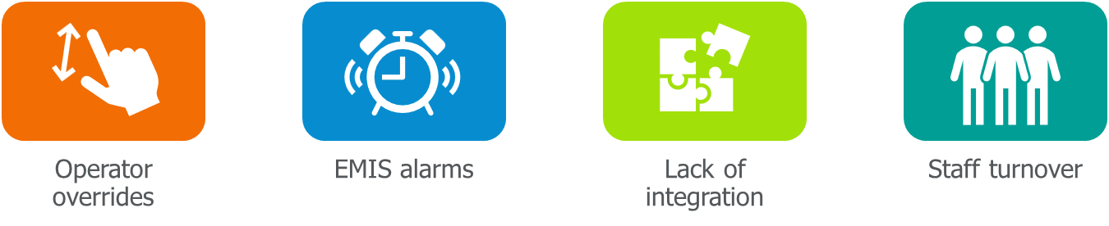
Operator overrides
This occurs often under production pressure. For example, a line operator might override an energy-efficient setpoint to increase throughput, especially if there is a backlog or if quality issues arise. These overrides often go unreported or undocumented.

EMIS alarms
These systems can generate numerous alerts, and people stop paying attention over time if there are too many alerts or if they are not reviewed consistently. Alarms get disabled, ignored, or deprioritized.

Lack of integration
If energy performance is not baked into your maintenance plans, shift huddles, or standard operating procedures (SOPs), it tends to be overlooked, out of sight, out of mind.

Staff turnover
When experienced personnel leave, so does their knowledge of how systems should be operated and maintained for efficiency. If processes are not well-documented, the next team starts from scratch, and previous gains can be lost.
Have you experienced any of the issues listed above? What were the consequences?

Case Study: Compressed air system regression
A mid-sized manufacturing plant implemented an EMIS to monitor equipment, including a compressed air system, to track energy consumption, system pressure and compressed air demand. The EMIS helped the energy team identify several improvement opportunities that included:
- Repairing leaks throughout the plant
- Reducing overall system pressure
- Implementing automated shutdown procedures for nights and weekends

Initial savings: 8%. Six months later, the system was only showing a 2% energy reduction.

What Might Have Gone Wrong?
Operator overrides | - Did the system pressure slowly increase over time?  - Were operators overriding the automated shutdowns?
EMIS alarms | - Were appropriate alerts in place?  - Were alerts going ignored or disabled?
Lack of integration | - Were leaks reappearing without being tracked and addressed?  - Were there changes to the system without updating the EMIS structure?  - Were EMIS data being monitored regularly after the initial improvements?  - Were people following standard operating procedures?
Staff turnover | - Were new staff trained on the shutdown protocols?  - Were staff trained on EMIS responsibilities?

Risks that can lead to Savings Degradation
When managing your EMIS, it is important to understand the risk factors that can contribute to savings degradation over time.
Retooling or operational changes | If your facility frequently changes equipment or operations, there is a greater risk that the EMIS will not be properly maintained.
Shift changes or staff turnover | The more frequent staff changes occur, from either shift changes or turnover, the more likely it is that the EMIS will not be properly maintained, monitored or alerts acted on.
Lack of training | If there is not adequate training either for EMIS operators or staff who will interpret EMIS data or notifications, the EMIS will not likely be maintained or desired actions will not be taken.
No proper documentation | A lack of adequate documentation around EMIS processes increases the risk of the EMIS not being maintained or used effectively over the long term, particularly when staff turnover occurs.
No Ownership | A lack of clear ownership over EMIS operation and maintenance increases the risk that no one maintaining the EMIS or people who are not qualified will change it, which will impact results.  A lack of clear ownership over EMIS alerts or other prompts runs the risk of people seeing such instances as someone else’s job and issues not being resolved.

Case Study: North Found Metals
North Found Metals is a medium-sized die casting facility. They have stable operations; changes to staff and product lines are infrequent. They recently implemented an EMIS that collected energy data from all significant energy users, including furnaces, injection equipment, cooling systems, compressed air, exhaust and make-up air units, space heating, lighting and others.
This project was championed by the facility energy manager who led the scoping, selection, implementation and roll out. That manager played a critical role in setting up the EMIS, monitoring the data, identifying opportunities and directing actions to the different teams and shifts, leading to a 7% energy reduction within just three months.
Alarms are set up to identify potential issues and occurrences of energy waste. These are communicated daily through an email sent to all managers and team leads and containing a list of current alarms.
Some teams conduct weekly reviews of energy data, but this is inconsistent.
Access to the EMIS has been restricted to the energy manager and the plant manager to minimize staff training requirements and reduce the risk of staff unintentionally interfering with EMIS operations.
Given this limited access and efforts being led by the energy manager who has a lot of experience with EMISs and building automation systems (BASs), no documentation on standard processes has been developed.
What are the biggest risk factors with respect to sustaining EMIS operational savings?

EMIS savings degradation risk checklist
Use this checklist to evaluate risks in your facility. For each item, ask,
“Is this being done consistently? If not, what could go wrong?”
1. Ownership and accountability
- A specific person or persons are assigned to monitor EMIS data daily or weekly
- Department leads and shift supervisors know their EMIS-related roles
- Alarms and notifications are acted on, not ignored or disabled
- Escalation procedures exist for unaddressed energy issues
- Overall EMIS performance, including whether issues are identified and corrective action taken, is reviewed on a consistent basis
2. Documentation and SOPs
- Key EMIS-related tasks are documented in SOPs or checklists
- Alarm response procedures are defined and communicated
- System settings (e.g. pressure setpoints) are documented and reviewed
3. Training and knowledge transfer
- All relevant staff have been trained on EMIS use and energy-saving practices
- A plan is in place for onboarding new staff
- Training materials or refreshers are accessible
- Access is restricted to trained staff
4. Shift changes/staff turnover
- Staff on all shifts are trained on their EMIS-related responsibilities
- Corrective actions resulting from EMIS findings are communicated to all shifts and relevant standards procedure documentation is updated
- Appropriate EMIS-related training is included as part of staff onboarding
5. Retooling or operational changes
- Changes to equipment or operations that may impact the EMIS are documented
- Equipment changes or process shifts trigger EMIS review or retuning
- EMIS alarms are updated to ensure they are relevant and focused on key issues
- Setpoints and other parameters are regularly reviewed to ensure they are relevant and represent best practice

What is the biggest risk in your facility?
- _____________________________________________________
Key elements of Sustaining EMIS savings
Sustaining EMIS savings does not occur by accident. It requires intentional design, accountability and integration of good EMIS practices into day-to-day operations.
1. Management commitment (resources and accountability)
Without a commitment from management to maintaining the EMIS, the latter is unlikely to sustain savings. This includes resources to maintain the EMIS and provide appropriate training and staff resources. In addition, management must hold people accountable for energy performance. Examples include:
- Leadership ensures that trained staff are available to maintain the EMIS and has established an annual budget to maintain and update the EMIS
- A manufacturing VP includes monthly EMIS performance reviews in executive meetings to maintain visibility and pressure for follow through
2. Clear ownership and responsibilities
Without clear ownership, opportunities fall through the cracks. You need someone responsible for each major system – compressed air, heating, ventilation and air-conditioning (HVAC), process controls, etc. That person is ultimately responsible for reviewing and maintaining the energy performance of that system. Other responsibilities, such as who is responsible for corrective action, should also be clearly documented and communicated. Ownership for maintaining the EMIS should also be assigned to provide clarity as to who is responsible for making any changes to the system. Examples include:
- Plant manager requires each department to assign an energy point person responsible for energy performance in their department
- Specific individuals are identified and documented so, when alerts are issued, it is clear who should receive them and be responsible for resolving them
3. Regular reviews and corrective actions
Energy performance data must be regularly reviewed, irregularities or non-conformities identified and corrective action taken. These relate to opportunities to save energy and opportunities to improve the effectiveness of the EMIS and associated processes. Examples include:
- Teams review their energy performance on a weekly basis to identify issues or opportunities
- The performance of the EMIS, including how long it takes to resolve alerts, is reviewed on an annual basis to identify improvement opportunities
4. Accessible and actionable data
Data have no impact if no one consults them. Use dashboards to make performance visible on a screen in the control room, and these can be shared in shift huddles or emailed in a simple monthly report. Using the correct KPIs can help provide actionable insights into changes in energy performance. Examples include:
- An automotive supplier developed line-level energy KPIs (e.g. kWh/unit) and aligned them with department goals
- A die casting facility used EMIS data to generate weekly dashboards sent to all supervisors with traffic light performance ratings
5. Integration into processes
Energy data should not be an add on; such data should be built into existing processes. Morning scrums that serve to discuss production issues should also cover energy performance. Preventative maintenance programs should address all alarms and use energy performance data to identify potential issues. Actions to reduce energy waste identified by the EMIS should be built into process documentation and standard operating procedures. Examples include:
- Shutdown checklists that include energy items like compressed air isolation and idle equipment verification
- Project processes for retooling presses include steps for verifying EMIS setpoints and reactivating control schedules
6. Training and reinforcement
All staff should receive EMIS training appropriate to their role whether they maintain the EMIS or interpret its outputs. Reinforcement is also critical and includes checking that people are following procedures and providing recognition for sustaining or improving energy performance. Examples include:
- EMIS training relevant to specific roles is incorporated into all staff onboarding
- A maintenance supervisor can create a monthly energy update email that summarizes key wins, anomalies, actions taken and recognition for staff contributions

7. Continuous improvement
Finally, all these processes should fall within a continuous improvement framework of
plan → do → check → act. Examples include:
- Opportunities identified, alerts issues, alerts resolved and actions taken are all tracked, documented and reviewed to ensure EMIS benefits are sustained
- EMIS operations are included as part of annual facility energy management system audits to verify if correct processes are being followed and to develop corrective actions if non-conformities are found
Which of these are strong at your facility? Which need improvement?

Building Your Sustainment Plan
Use this template to begin drafting your facility operational savings sustainment strategy. Start with one system and refine it with your team post-workshop.
Section 1: System and owner
System name: ________________________________________________
(e.g. compressed air, HVAC, process cooling)
Primary owner: ______________________________________________
(Who is accountable for system performance and follow-up?)
Support roles: _______________________________________________
(maintenance crew, operators, energy champions, etc.)

Section 2: KPIs and review schedule
Primary energy KPI: ___________________________________________
(e.g. kWh/unit produced, pressure deviation %)
Target or threshold: ___________________________________________
(e.g. <3% deviation, 10% below baseline)
Review frequency: ☐ Daily ☐ Weekly ☐ Monthly ☐ Other: ___________
(When will performance be reviewed?)
Who reviews the KPI? _____________________________________________
(e.g. energy team, production supervisor, shift lead)
Review method: ☐ Dashboard ☐ Report ☐ Meeting ☐ Other: __________

Section 3: Escalation and communication approach
Trigger for escalation: _________________________________________
(e.g. performance drops for >2 days, KPI missed for 2 cycles)
Escalates to: _________________________________________________
(e.g. maintenance manager, plant manager, energy committee)
Corrective action process: _____________________________________
(e.g. root cause review, SOP update, retraining, maintenance ticket)
Communication tool: ☐ Notice board ☐ Email update ☐ Team meeting ☐ Other: __________

Parting thoughts
What is one thing you will do differently to ensure EMIS operational benefits are sustained?

Additional Resources

EMIS Incentives
- Save on Energy: Expanded Energy Management Program

EMIS Planning Resources
- Natural Resources Canada: Energy Management Information Systems Planning Manual and Tool.
  - Note: if you end up in an endless loop of clicking “Continue to publication”, right-click the “Continue to publication” button and select “Save link as…” to save the PDF to your computer.
- Natural Resources Canada: EMIS Business Case Tool

