The Road to ISO 50001
Participant Workbook
ISO 50001 is the international standard for good energy management practices. It leads to greater and longer-lasting energy savings and improves the resilience and persistence of your efforts. But achieving ISO 50001 certification can require considerable time, human resources, and money.
Use this workbook in conjunction with “The Road to ISO 50001” workshop to understand what is involved in achieving ISO 50001 certification, if it is right for you, and how you can work towards 50001 to take advantage of the benefits without becoming overwhelmed.

In this workshop, participants will:
- Learn what is involved in ISO 50001, including best practices and what commitments are required.
- Evaluate whether ISO 50001 certification is right for their organization.

- Develop a plan to work towards ISO 50001
in a way that makes sense for them.

This workshop will be
hosted over Microsoft Teams.
For support using Teams, see the last page of this workbook.

What is ISO 50001?
ISO 50001 is a standard that establishes requirements for an ISO-certifiable Energy Management System (EnMS).
This EnMS must include specific components outlined in the ISO 50001 standard, including established targets and action plans and processes to support achievement of those targets. It must also include formal, documented, and auditable continuous improvement processes (Plan-Do-Check-Act).
While not officially broken down into these components, practically, ISO 50001 can be seen as being made up of three aspects:
  Energy Management Good Practices | 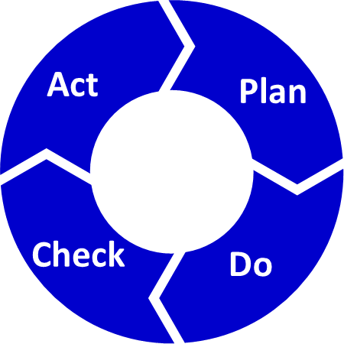  Plan-Do-Check-Act | 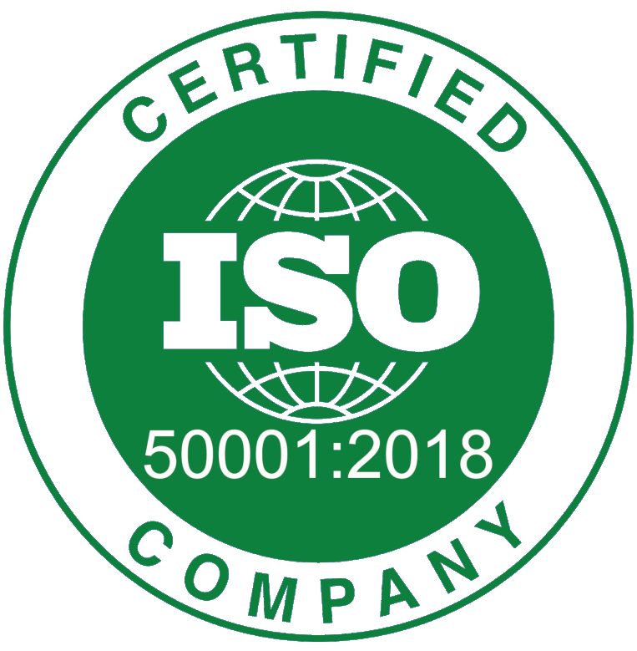  3rd-party Certification

Energy Management Good Practices
Energy management good practices include things like establishing an energy policy and energy team, managing significant energy users, and monitoring and reporting on energy key performance indicators that will help organizations eliminate energy waste and reduce energy consumption.

Plan-Do-Check-Act Processes
Plan-Do-Check-Act (PDCA) processes under ISO represent a formal system of continuous improvement where the process of identifying opportunities to improve, implementing those improvements, checking that people are acting in compliance with those improvements, and then identifying corrective actions is conducted on a regular schedule and is well documented so that these efforts can be auditable.

Third-party Recognition
Third-party certification is used to verify compliance with the ISO 50001 standard though regular audits of the organization’s energy management practices and PDCA processes.

Identifying your Interest in An Energy Management System
Your first step in assessing what path to ISO 50001 is right for you is to understand what is driving that desire. Below are three main aspects of an ISO 50001 with the typical benefits or motivators associated with each of the aspects.

Aspects of ISO 50001 and Motivators
ASPECt of ISO 50001 | Motivators
Energy Management Good Practices | - Reduce energy costs.  - Improve energy reporting.  - Reduce GHG emissions.  - Establish a plan to achieve targets.
Plan-Do-Check-Act | The benefits of implementing energy management good practices, plus:  - Improve adherence to energy management practices.  - Enhance persistence of energy savings.  - More actively pursue continuous improvement.  - Increase internal awareness of energy management.
Third-party Recognition | The benefits of implementing energy management good practices and PDCA process, plus:  - Comply with regulatory requirements.  - Meet customer requirements.  - Enhance brand.  - Access funding programs.
Identify your biggest 2-3 motivators and either highlight them in the table above or write them in the box below.

Which End Goal is Right for You?
Now that you understand your primary drivers, you can choose an end goal that delivers the right balance of meeting your needs and the effort involved in implementation.
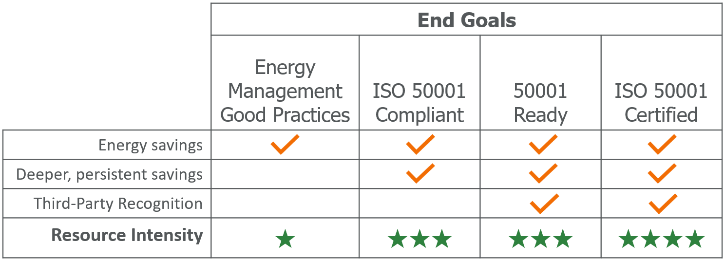
- Energy Management Good Practices means implementing energy management processes to help you establish and achieve energy reduction targets.
- ISO 50001 Compliant means implementing all of the energy management practices identified in the ISO 50001 standard including formal, documented, and auditable PDCA processes.
- 50001 Ready means registering and completing all the tasks in the 50001 Ready Navigator and submitting your self-attestation for approval.
- ISO 50001 Certified means engaging a registrar to conduct a third-party auditor and verify your compliance with the standard.
Based on your primary motivators and available resources, which of the four options would be your current end goal?

Check or highlight one option from the list below.
- Establish energy management good practices.
- Achieve ISO 50001 compliance.
- Achieve 50001 Ready recognition.
- Achieve ISO 50001 certification.

Choose your Timeframe
Once you’ve identified your end-goal, the next step is to understand your timeframe. Typically, organizations on the road to 50001 can be categorized into having one of the following timeframes: short-term, long-term, or undetermined.
Timeframe | Motivators | End Goal | Resource Commitment
Short-term | Strong motivators associated with third- party recognition. | Achieve ISO 50001 compliance, recognition, or certification within 10-24 months | Able to commit significant resources.
Long-term | Some motivators associated with third- party recognition. | Achieve ISO 50001 compliance, recognition, or certification in 2+ years | Able to commit moderate resources.
Undetermined | Primarily motivators associated with energy management good practices or PDCA processes. | Establish energy management good practices. | Able to commit some resources.

Even if achieving ISO 50001 compliance is not your current end goal, staying on the road to 50001 with an undetermined timeline can help ensure your current efforts are still aligned with ISO 50001 requirements in case your motivators change in the future.

Considering your motivators, desired end-goal, and available resources choose the timeframe that you think would be most appropriate for you:
- Short-term (10-24 months)
- Long-term (2+ years)
- Undetermined

Internal versus external Resources
Regardless of your end-goal and timeframe, implementing change is going to require resources who are knowledgeable about energy management good practices and ISO 50001 processes. Some organizations will achieve their end-goals entirely with internal resources, while others will make use of external consultants.
Consider the summary points regarding internal and external resources given in the table here:
Internal Resources | External Consultants
- Will need internal resources to maintain good practices and ISO 50001 processes, even if an external consultant is used to support implementation.  - May require training on energy management good practices and ISO 50001 processes.  - Hiring staff with energy management or ISO 50001 experience can accelerate your efforts. | - Likely required to achieve short-term implementation timeframes.  - Reduces training requirements for internal staff to achieve implementation.  - May support staff training to maintain good practices and ISO 50001 processes.

Information and Support Resources
There are several resources available to support your road to 50001, regardless of your end-goal and timeframe.
Remember, even if ISO 50001 isn’t your current goal, aligning your energy management good practices with the ISO 50001 standard will help prepare you in case your end-goal changes.
- ISO 50001 Training Courses can provide your team with an understanding of the standard and experienced instructors can help them see what implementation can look like for your organization.
- 50001 Ready Navigator translates the standard into actionable tasks in a logical sequence and provides guidance and tools to help along the way. It tracks your progress and is required to achieve 50001 Ready navigation.
- Strategic Energy Management Program provides ongoing training and coaching support to implement and improve energy management practices aligned with the standard.
The above resources provide different levels of and types of support and can be very effective when used in combination.

Getting Started on your road to 50001
Identifying your key motivators, desired end-goal, and likely timeframe is an excellent start down the road to 50001. Your next step will likely be to build upon today’s work to gain consensus around this plan within your organization.
Once that’s achieved, a common starting point is to conduct an Energy Management Assessment (EMA) to identify gaps to address along your road to ISO 50001.
This can be done via:
- A third-party consultant
- Your coach in the Strategic Energy Management Program
- Using the 50001 Ready EMA tool (see bottom of page)
- SEM Hub Energy Management Assessment Tool
- ISO 50001 Gap Analysis Checklist

Additional Resources

ISO 50001 and certification
- The ISO 50001 Standard
- 8-step process to ISO 50001 certification
- How to prepare for your ISO 50001 Registration Audit
- Registrar Resource Center

50001 Ready
- 50001 Ready Canada
- 50001 Ready Canada Navigator

Support through Save on Energy
- Training and Support
- Energy Manager Support Services
- Strategic Energy Management Program
- Energy Management Learning Platform
Teams Instructions

Joining the Workshop
If you are not familiar with Teams, please see the following links for instructions on how to join. You can also join a test meeting by following these instructions to familiarize yourself with using Teams.
- How to join a Teams meeting (app or web)
- How to join a Teams meeting in Microsoft Teams (free version)
- How to join a Teams meeting without a Microsoft Teams account
- How to join a Teams meeting by phone

If you are having trouble connecting, please see the following resources on troubleshooting when you can’t join a Teams meeting.

TEAMs Features Used in this Workshop
Raise your hand  - At the top of your screen, click Raise.  - A hand should show up next to your name under Participants.  - To lower your hand, click Raise again.    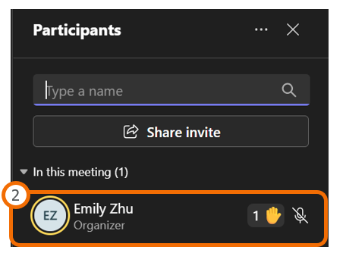 | use the chat to ask questions  - To use the chat, click Chat at the top of your screen.  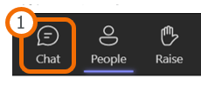  - The chat should appear on the right side of your screen. Type your message in the message box.  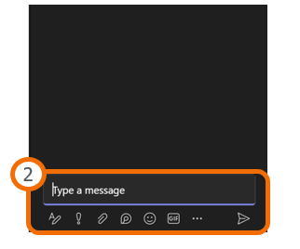

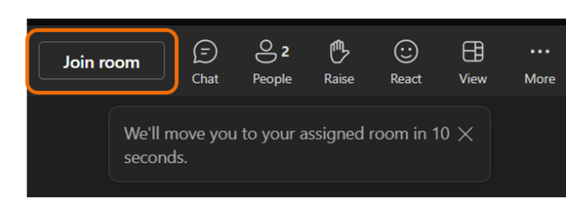
Joining a Breakout Room
When a breakout room is opened, you will see a button at the top of your screen labelled ‘Join Room’. Click the Join button to begin the breakout.

