

Pathways to efficient industrial electrification
Participant Workbook

Industrial organizations are increasingly exploring electrification as a key strategy for reducing greenhouse gas (GHG) emissions. Yet, the path forward is not always clear. Electrification in industrial settings involves unique challenges, from high-temperature process needs to complex system integration and infrastructure limitations.

This workshop offers a practical, sector-informed roadmap to help industrial professionals identify, assess and begin planning for efficient electrification opportunities. Participants explore proven and emerging technologies, alternatives to traditional thermal processes, key system-level considerations to support effective decision-making and strategies to support electrification plans in the face of uncertainty.

In this workshop, Participants will:
- Learn about why industrial electrification matters​
- Map temperature-specific opportunities​
- Understand how process changes enable electrification​
- Evaluate common constraints and enablers​
- Understand and apply strategy frameworks
This workshop is hosted via Microsoft Teams.
For instructions or troubleshooting, please
see the last page of this workbook.

industrial electrification matters

What is driving decarbonization?

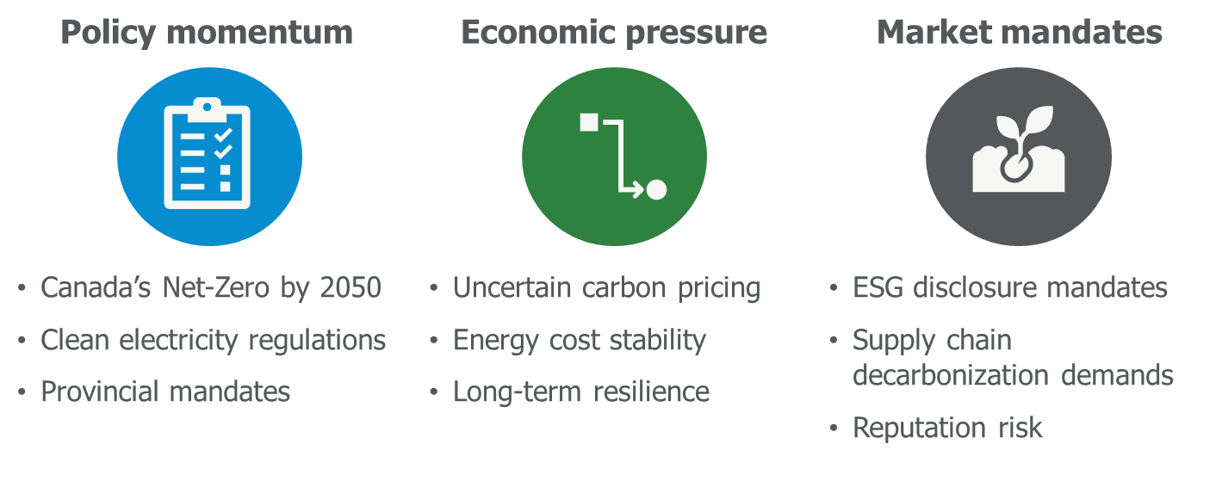

- Canada’s total GHG emissions in 2023 were dominated by energy-related sources.
- Combined, industry-related emissions exceed 50% of Canada’s total.
- Stationary combustion (e.g. industrial heating) is the largest contributor at 43%.
- Transport is the second largest, contributing 28%.
- Industrial sources also include 8% from industrial processes and product use (IPPU).
- Industrial process heating is a key target for electrification and decarbonization.
- Electrifying industrial heat will significantly reduce emissions if paired with clean electricity.

Why Electrification is a Key Decarbonization Pathway

Energy-efficiency measures are critical — but not enough on their own. To achieve net-zero, industrial subsectors must directly replace fossil fuel combustion with clean electricity.
Eliminates on-site combustion
- Replaces fossil fuel heat with clean electricity
- Essentially eliminates Scope 1 emissions rather than incrementally reducing them through ongoing efficiency efforts
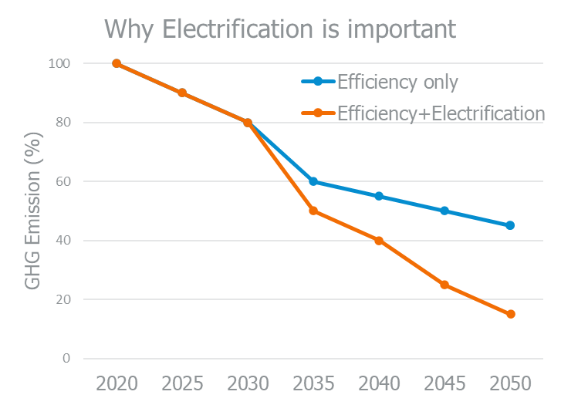
Efficiency alone ≠ net zero
- Even major efficiency projects (e.g. a 40% natural gas reduction) leave significant residual emissions.
- Remaining fossil fuel use will require offsets or carbon capture — both costly and uncertain.
Co-benefits beyond emissions
- Lower maintenance (fewer moving parts, no combustion residue)
- Improved workplace safety (no combustion gases)
- Often higher precision in process control

NoteS:

why is industrial electrification not Increasing faster?

 | Infrastructure constraints | Electrical capacity, aging transformers, limited-service upgrades  Site layout/design limitations for new electrical systems
 | Lack of available technologies | Limited high-temperature electric options  Performance gaps for certain applications  Integration challenges with existing processes
 | Perceived high costs and low return on investment (ROI) | Upfront capital costs seen as prohibitive  High cost of electricity versus fossil fuels  (spark gap)  Short payback thresholds filter out longer-term electrification opportunities
 | Misconceptions/ lack of awareness | “Electric solutions are not available for high-temperature processes”  Confusion between efficiency upgrades versus electrification  Underestimating co-benefits such as safety or reduced maintenance

What do you believe is the biggest barrier to industrial electrification?

Lack of available technologies

High upfront costs

Electrical infrastructure limitations

No internal support or leadership

Not a priority right now

Other:

Case Study: 3M – advanced manufacturing
- Committed to net-zero GHG emissions by 2050, and they are targeting a 50% reduction in Scope 1 and 2 emissions by 2030.
- One of the most relevant aspects of 3M’s decarbonization strategy is their focus on electrifying process heat, especially in high-precision areas like cleanrooms where they are piloting infrared (IR) drying.
- What is driving this shift? It is not just about carbon, it is also about safety, better process control and responding to investor environmental, social and governance (ESG) expectations.
- They have recognized that efficiency improvements alone will not get them to net zero — electrification is essential.

Case Study: Cascades – pulp and paper (Canada)
- They have set a goal to reduce Scope 1 and 2 emissions by 38% by 2030.
- Their actions include process redesign to reduce heat demand and shifting from fossil fuel to electric heating and drying systems, especially viable in Quebec where the grid is already 99% clean.
- One takeaway here is how regional grid carbon intensity plays a major role. For Cascades, operating in Quebec allows them to achieve substantial emission reductions by switching to electricity with relatively minor equipment changes.
- Their plan is also supported by provincial electrification incentives, which highlights the importance of understanding local funding programs and policy support.
- Cascades is a great example of combining process change with grid opportunity.

Case Study: ArcelorMittal Dofasco – steel (Ontario)
- They have committed to a 60% GHG reduction by 2030, primarily through one major shift: replacing coal-based blast furnaces with electric arc furnaces (EAFs).
- This transition alone is projected to cut three million tonnes of CO₂ emissions per year.
- It is important to note that electrifying steel production is capital-intensive, but this project received over $400 million in federal funding through the Strategic Innovation Fund.

Five pillars of decarbonization stratergies
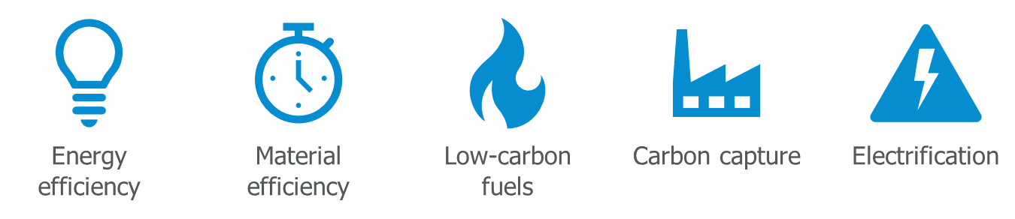
The US Department of Energy’s (US DOE) Industrial Decarbonization Technology Roadmap identifies process temperature as a primary determinant of electrification feasibility.
The roadmap categorizes decarbonization strategies into five pillars (energy efficiency, electrification, low-carbon fuels, carbon capture and material efficiency), but the viability of electrification varies strongly with process heat temperature.
Electrification is most feasible and impactful in low to medium-temperature applications.
Higher-temperature processes will require technological breakthroughs, alternative fuels or non-thermal substitutes in the near term.
TEMPERATURE DRIVES TECHNOLOGY
Industrial electrification depends heavily on process temperature, which determines the type of heating application.
  Low temperature  Common processes include space heating, washing, pasteurization and other low-temperature applications. |   Medium temperature  Common processes include food processing and paint curing.
  High temperature  Common processes include metal treatment as well as glass and ceramic production. |   Very-high temperature  Niche applications only

BREAKOUT ROOM:
In your breakout room:
- Discuss what fossil fuel-based heat sources are at your facility
- Classify each process by heat source and temperature range
- Estimate the % of total fossil fuel consumption for each
Aim for the best estimates you have today — precision is not required.
Process | Heat source  (fuel type) | Temperature range | % fossil fuel consumption

ELECTRIC TECHNOLOGIES BY PROCESS TEMPERATURES

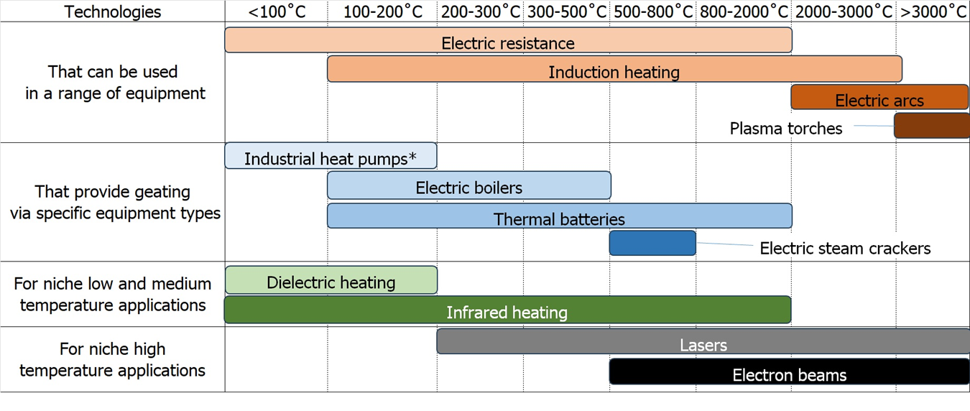
*Up to 160˚C, some up to 200˚C
Industrial electrified heating technologies and their ranges (image credit: Energy Innovation)

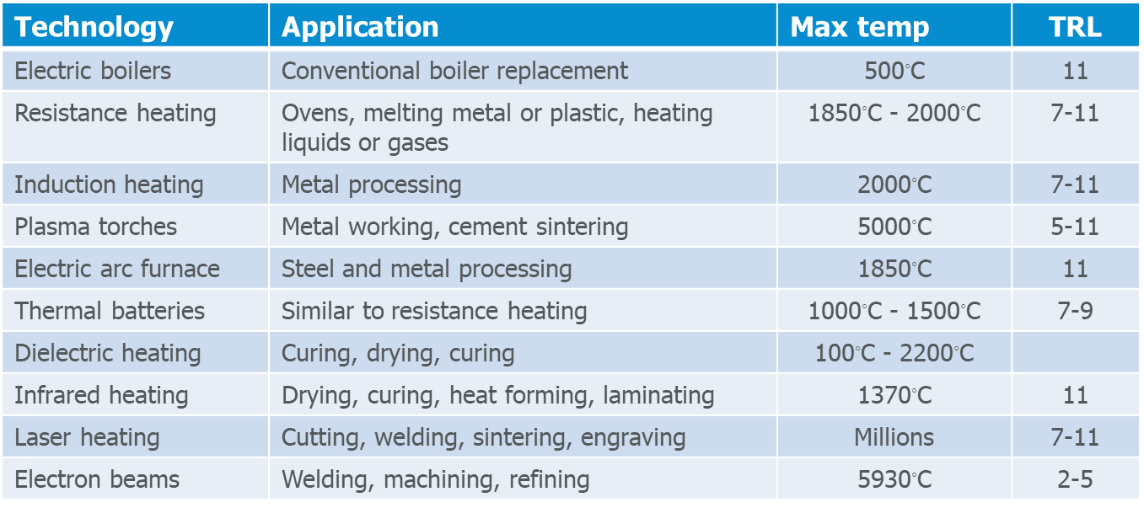

INDUSTRIAL HEAT PUMP TECHNOLOGY READINESS LEVEL BY TEMPERATURE RANGE

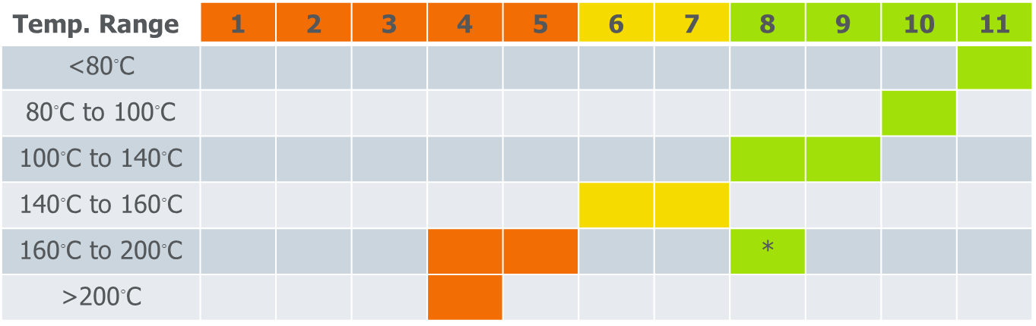
Source: IEA. World Energy Report Special Report. The Future of Heat Pumps. 2022

SECTOR-SPECIFIC SUCCESS STORIES
La Brea Bakery (California)
Technology adapted: induction heating, temperature range of 2,000˚C with a technology readiness level (TRL) of 11
- Process: transitioned from natural gas convection ovens to electric infrared ovens for artisanal bread baking
Outcomes:
- Achieved 30% reduction in energy consumption in the baking process
- Improved bake consistency and reduced warm-up time
- Enabled precise zoning and modular control, reducing waste during start-up and shutdown
- Why it matters: infrared heating delivers fast, efficient heat transfer ideal for surface-dominant processes like baking and toasting.

What about applications where an appropriate technology
is not currently available or FEASIBLE?
- Direct electrification is not always plug-and-play:
Many industrial processes are designed around fossil fuel technologies. Simply replacing a gas burner with an electric heater may not be technically feasible, cost-effective or operationally viable.
- Process temperatures often exceed the efficient range of electric technologies:
Technologies like heat pumps or electric boilers work well at lower temperatures. If you can reduce the required process temperature, you expand your electrification options and reduce energy demand.
- Electrification can require rethinking the process, not just the equipment:
Example: instead of high-temperature, short-duration pasteurization, a facility might switch to longer, lower-temperature processes that are better aligned with electric heat sources.
- Redesign can unlock new non-thermal technologies:
Switching from thermal to mechanical or chemical processes (e.g. replacing thermal drying with membrane separation or UV curing) may enable full decarbonization pathways.
- Process redesign supports modular and hybrid systems:
Instead of centralized high-heat systems, companies can shift toward modular electric units, improving flexibility, redundancy and capital deployment across facilities.
- Rethinking processes now can futureproof your facility:
Making process changes early enables smoother transitions to electrified systems as technologies are improved and policies tightened. It also avoids locking in GHG emissions through long-lived fossil infrastructure.

FRAMEWORK FOR PROCESS CHANGE TO ENABLE ELECTRIFICATION
- Many industrial heat applications are designed around fossil fuels.
- Electrification may require rethinking how heat is used, not just what energy source is used.
- The five process-change strategies help unlock electrification where direct substitution is not viable.

Examples of process changes to enable electrification
Lower temperature alternatives | - Reduce pasteurization temperature but hold at the temperature for longer  - Use catalysts or additives to decrease required temperature for reactions or material melting  - Lower drying temperature by increasing residence time  - Cold sintering for ceramics
Mechanical substitution | - Mechanical dewatering (screw presses, centrifuges, belt filter presses, vacuum belt driers)  - Mechanical filtration or membrane separation  - Self-piercing rivets
Non-thermal or chemical alternatives | - UV curing of coatings  - Chemical UV or other sterilization approaches  - High-pressure processing for pasteurization  - Desiccants  - Chemical strippers instead of thermal stripping
Modular or batch operations | - Replace central boiler with multiple point-of-use heating units  - Modular high-turndown efficiency systems to facilitate future hybrid or full electrification
Hybrid or transitional systems | - Duel-fuel systems  - Electric pre-heating  - When doing other work, consider oversizing electrical infrastructure

GROUP DISCUSSION – RETHINKING YOUR PROCESS
Thinking of your heat sources that may be challenging to electrify
Refer to:
- Your industrial heat processes you wrote down on page 6.
- The electric heating technologies on page 7 and page 8.
Think about the following and write down your answers:
- Can the process be operated at a lower temperature?
- Can the function be replaced with a mechanical, chemical or non-thermal step?
- Can the process be broken into smaller units or shifted to batch?
- Can the heat source be hybridized as a transitional step?
Process | Is there an electric heat source that might be able to replace it? | Is there a potential process change that can help enable electrification?

Prioritizing and planning your electrification
Short term | - Low-cost optimization  - Cost-effective efficiency upgrades  - Cost-effective electrification, for example:  - Steam tracing  - Applications with production benefits
Medium term | - End-of-life upgrades  - Avoid locking in high-emission systems  - Plan for deeper retrofits, for example:  - High-temperature systems  - Process changes
Long term | - Change processes  - Integrate new technologies for high-temperature applications, for example:  - High-temperature heat pumps  - Other technologies

Electrification COnstraint Checklist
Use the checklist below to identify site-specific barriers before planning an electrification project. Tick all that apply and note any related details.
1. Electrical infrastructure
☐ Limited transformer capacity or service size
☐ Inadequate distribution (e.g. undersized panels, feeders, switchgear)
☐ Utility interconnection delays or complex approval processes
☐ Voltage or power quality limitations for sensitive electric equipment
2. Process/operational
☐ Downtime limitations for equipment changeover
☐ Heat source located far from process loads, making conversion complex
☐ Thermal system tightly integrated with other process steps
☐ Variable load profiles that challenge electric technology efficiency
3. Control systems
☐ Legacy controls incompatible with electric technologies
☐ No capability for advanced sequencing or demand response
☐ Limited real-time monitoring of process energy use
4. Economic/financial
☐ High capital cost versus available budget
☐ Long payback period outside corporate thresholds
☐ Lack of internal carbon pricing or lifecycle cost evaluation
☐ No financial mechanisms for pilot or demonstration projects
5. Organizational/cultural
☐ Operator familiarity with combustion systems but not electric systems
☐ Perceived risk of altering established processes
☐ Limited cross-department coordination for decarbonization projects
☐ Competing priorities overshadow GHG reduction goals
6. External/policy
☐ Lack of clear regulatory signals or long-term carbon policy
☐ No or limited utility/industry incentives
☐ Uncertainty in fuel/electricity price forecasts
☐ Trade exposure risk if competitors retain cheaper fossil fuel processes

Electrification Enablers Checklist
Use the checklist below to identify strengths or conditions that could accelerate your electrification projects. Tick all that apply and add notes where relevant.
1. Ample electrical capacity
☐ Existing service has spare capacity for added electric loads
☐ Utility has a streamlined upgrade process
☐ On-site substation or feeders sized for future load growth
2. Clean, low-cost grid electricity
☐ Low-carbon intensity electricity (e.g. BC, Quebec, Manitoba)
☐ Competitive rates versus fossil fuel costs
☐ Time-of-use or demand response pricing that benefits electrification
3. Planned capital projects
☐ Major thermal equipment near end of life
☐ Planned facility expansion, modernization or reconfiguration
☐ CAPEX budget placeholders for enabling infrastructure
4. Supportive leadership and culture
☐ Executive commitment to GHG reduction and net-zero targets
☐ Sustainability key performance indicators (KPIs) in corporate performance metrics
☐ Internal champions with authority to move projects forward
5. External incentives and funding
☐ Utility or provincial retrofit incentive programs
☐ Federal decarbonization funding (e.g. Strategic Innovation Fund, Clean Growth Program)
☐ Low-interest financing for clean technology adoption
6. Proven technology fit
☐ Vendor solutions demonstrated in similar processes
☐ Peer case studies available with performance and ROI data
☐ Technology maturity level supports immediate deployment

FROM INSIGHT TO ACTION: BUILDING YOUR ELECTRIFICATION STRATEGY
UNCERTAINTY AS A PLANNING FACTOR
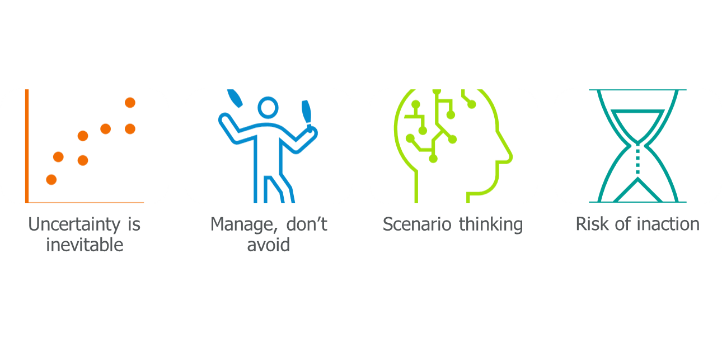
Uncertainty is inevitable – Technology gaps, policy shifts or market volatility are normal in long-term industrial planning, especially for electrification.
Manage, do not avoid – Instead of waiting for perfect clarity, use adaptive planning, staged investments and pilot projects to move forward while remaining flexible.
Scenario thinking – Develop multiple pathways (e.g. electrify now versus wait for next generation technology) and assess the triggers that would cause you to shift course.
Risk of inaction – Delaying without a plan can lock in fossil fuel infrastructure, raise future compliance costs and reduce competitiveness.

Strategy Framework for Industrial Electrification Planning
This framework helps facilities plan electrification efforts strategically, accounting for uncertainty, constraints and long-term capital planning cycles.
1. Start with what can be done now
- Identify low-risk, high-impact opportunities (e.g. replace fossil fuel-based makeup air unit, add controls)
- Focus on quick wins that are aligned with current maintenance or operations budgets
- Bundle with existing initiatives (e.g. energy efficiency, ESG targets)
- Consider co-benefits: maintenance reduction, process control, safety
2. Identify knowledge or technology gaps
- List processes or end-uses wherein electrification is desirable but not immediately feasible
- Determine whether a limitation is due to technology maturity, lack of internal expertise or product/process validation requirements
- Plan to address through:
    - Pilot projects
    - Vendor engagement
    - Research partnerships
    - Site-specific studies
3. Build in decision gates and triggers
- Connect electrification opportunities to capital asset timelines:
    - Equipment nearing end of life
    - Facility expansion or renovation
    - Scheduled CAPEX planning windows
- Define triggers for revisiting decisions:
    - Carbon price threshold
    - New incentive program launch
    - Demonstration project success
    - Equipment failure or retrofit opportunity
    - Use structured decision frameworks to assess readiness (e.g. go/no-go checkpoints)
4. Design for flexibility and avoid lock-in
- When replacement with electrified systems is not feasible now:
    - Choose modular or hybrid systems that can evolve
    - Oversize electrical panels for future electrification
    - Design pipe chases, ducting or spaces for future equipment
- Avoid re-investing in long-life fossil systems unless future adaptation is possible
5. Integrate with broader business planning
- Align electrification with:
    - five or 10-year capital planning
    - ESG or compliance milestones
    - Facility lifecycle assessments
- Budget for enabling infrastructure (e.g. transformers, control systems)
- Communicate internally to ensure electrification is part of strategic conversations early on

BREAKOUT ROOM INSTRUCTION
Reflect on and discuss the following questions with your group. Take takeaway notes below:

      - What could be electrified in the next few years?

      - For which key decision gates will you need to plan?

      - How will you avoid locking in GHG emissions?

For more information

Save on Energy
- Training and Support: Decarbonization Strategies.
- Introduction to Efficient Electrification Toolkit.
- Integrated Design Best Practices Guide - Industrial.
- Integrating EV Charging in Buildings.

US Department of Energy
- Industrial Decarbonization Roadmap. 2022.
- Better Buildings. The (not so) shocking shift toward industrial electrification (2024 webinar recording).
- Better Plants. Industrial Electrification Assessment Framework. 2025.

Other Resources
- Industrial Heat Pump Alliance.
  - Industrial heat pump procurement toolkit.
- Agora Industry. Direct electrification of industrial process heat: An assessment of technologies, potentials and future prospects for the EU. 2024.
- ACEEE. Industrial Heat Pumps.
- ACEEE. Industrial Heat Pump Domestic Market. 2023.
- ACEEE. A scenario analysis of boiler replacement with industrial heat pumps. 2024.
- ACEEE. The industrial heat pump opportunity goes beyond energy savings. 2024.
- ACEEE. Using Industrial Heat Pumps to Rethink Thermal Loads. 2024.

