Getting started with Pinch analysis: Understanding opportunities

Participant Workbook
Use this workbook in conjunction with the “Getting started with pinch analysis: understanding opportunities” workshop to understand what is involved in achieving energy savings for your facility.

In this workshop, participants will:
- Learn the benefits of a pinch analysis in terms of energy, emissions and cost savings
- Assess if pinch analysis applies to your facility
- Identify next steps such as training, software tools or other support


This workshop is hosted over Microsoft Teams.
For support using Teams, see the last page of this workbook.

What is pinch analysis?
Pinch analysis is a systematic method in energy integration and process design that determines the minimum amount of external heating and cooling utilities required for a process by optimizing heat recovery between hot (heat-releasing) streams and cold (heat-demanding) streams.
At its core, pinch analysis:
- Combines all hot streams into one hot composite curve and all cold streams into one cold composite curve.
- Plots these curves on a temperature versus enthalpy (or heat flow) diagram and finds the pinch point — the closest approach between the curves (i.e. the smallest temperature difference), which defines the thermodynamic bottleneck for heat recovery.
- It then uses the pinch point to set targets for minimum hot utility (e.g. steam) and minimum cold utility (e.g., cooling water)—the external heating and cooling services beyond process heat recovery— to design the heat exchanger network above and below that point.

Summary of key terms
The following are common terms used in pinch analysis.
Hot stream
A process stream that needs to be cooled (e.g. a hot product, vapour or effluent). It supplies heat to cold process streams.

Cold stream
A process stream that needs to be heated (e.g., feedwater, raw material, or air). It receives heat from hotter process streams.

Heat recovery
The process of capturing heat from hot process streams that would otherwise be wasted and transferring it to cold streams.

Composite curves
Graphical plots used to visualize the thermal energy profile of a process:
- The hot composite curve represents all hot streams (temperature versus enthalpy).
- The cold composite curve represents all cold streams.
Their closest point of approach identifies the pinch point.

Pinch point
The temperature at which the hot and cold composite curves come closest together.
- Below the pinch → no external heating should be required.
- Above the pinch → no external cooling should be needed.
Violating this principle wastes energy.

ΔTmin (minimum temperature difference)
The smallest allowable temperature difference between hot and cold streams for feasible heat exchange:
- Determines design feasibility and cost trade-offs — smaller ΔTmin = more recovery, but larger exchangers and higher costs

Heat exchanger network (HEN)
The physical system of heat exchangers that achieves the targeted heat recovery:
- Pinch analysis output: Defines the optimal structure and stream matches for minimum utility consumption

Reflection box
Where in your facility could hot and cold processes be better integrated?
What are you hoping to accomplish with pinch analysis?

Case study: Energy recover in an Amonia Plant (Nitrogen-Based Fertilizer Industry)
Problem:
A 1,000 t/day ammonia plant faced high fuel and steam costs due to significant heat losses, especially from the reformer flue gas. The plant heat exchanger network allowed large amounts of recoverable heat to escape to the atmosphere (at a heat transfer rate of over 12 MW). Steam generation was inefficient, forcing reliance on auxiliary and package boilers.
Intervention:
A pinch analysis was conducted to identify integration opportunities. The analysis was focused on improving the process-utility interface rather than redesigning existing units.
Two key projects emerged:
- Increasing high-pressure steam superheat temperature
- Installing a feed gas saturator to recover waste heat and reduce steam injection requirements
These measures reused waste heat from reformer flue gas and optimized the site steam balance.
Impact:
- 30 t/h reduction in total steam demand
- Energy savings: ~2 GJ per tonne of ammonia produced
- Cost savings: ≈ CAN $3.75 million per year
- Natural gas and emission reductions: ~ 11% cut in CO₂ and NOₓ
- Payback period: ~ 1.5 years
- Enabled shutdown of package boilers, thus lowering maintenance and operating costs

Lesson learned:
Pinch analysis in retrofit conditions can reveal feasible, high-impact integrations without major process redesigns. Focusing on process-utility interactions rather than equipment replacements maximized efficiency gains at minimal cost.
Jot down any important insights from the case study and/or any questions you have for Emily and Nawfel.

recognize common misconceptions
Learn to identify and challenge common myths that limit the uptake of pinch analysis:
Experts will clarify that pinch analysis is a quantitative, system-level approach requiring specialized tools — not just intuitive reasoning — and that screening-level assessments can be simple and informative even before full modelling. We will illustrate how misconceptions can lead to missed opportunities for energy recovery or misallocated effort.

identifying myth or reality
Identity whether the following are fact or fiction and note any takeaways from the discussion and case studies for each of these:
- You can do pinch analysis in your head.

- Pinch analysis applies to one system or process.

- Pinch analysis is too complicated.

How might misconceptions affect decisions to get started with pinch analysis or take a more holistic approach to energy efficiency at your facility?

Identifying the types of facilities in Which pinch analysis can add value
Learn how to recognize where pinch analysis is most applicable by examining the process characteristics that enable meaningful heating and cooling integration. Experts will highlight how systems with multiple hot and cold process streams, or those that simultaneously heat and cool, offer the greatest savings potential.

Sector examples
Industry examples:
- Pulp and paper → multiple steam levels and overlapping heating/cooling (drying, washing, evaporation)
- Food processing → simultaneous pasteurization (heating) and chilling/freezing (cooling)
- Chemical manufacturing → complex reaction, separation and distillation systems with high heat loads

Institutional examples:
- Hospitals → simultaneous heating (domestic hot water, sterilization) and cooling (air conditioning)
- Universities → central energy plants with variable loads across buildings
- District energy → networked steam and chilled water plants serving mixed-use zones

Does my facility have these characteristics?
Check off all that apply:
☐ Large heating and cooling demand levels
☐ Multiple process streams at different temperatures
☐ High fuel or steam use
☐ Simultaneous heating/cooling cycles

Which case study examples are most like your site?

Assess Whether my facility is a good candiate
This section applies what you have learned to evaluate whether pinch analysis makes sense for your facility using simple screening criteria.

Screening tool
Identifying candidate facilities
Facilities with the following characteristics are most likely to have significant opportunities for thermal energy optimization:
☐ High overall thermal energy consumption — typically more than 100,000 GJ per year (or over 2,500,000 m³ in natural gas annually)
If you know your approximate overall thermal energy consumption, add it here:

☐ Broad and varied heating and cooling requirements
☐ Multiple process heat exchangers (i.e. not including the HVAC system)
☐ Both heating and cooling systems operating year-round
☐ Significant process steam usage (through indirect steam heating or direct injection)
☐ Energy-intensive process equipment such as dryers, boilers, evaporators, furnaces, distillation units or reactors
☐ Large compressors serving refrigeration, process gases or compressed air
☐ Observable waste (e.g. cooling towers, vents or heat rejection)

Typical industries
- Heavy industry: pulp and paper mills, chemical and petrochemical facilities, advanced gas processing plants and integrated metallurgical operations (e.g. steel production)
- Food and beverage: breweries, distilleries, sugar refineries, dairy operations, meat processors and edible oil refineries
- Other manufacturing: textile dye houses, ethanol plants and other energy-intensive processing sites

Outline potential next steps
This section helps you determine what kind of next step is appropriate for your facility — whether that is learning more, simply screening, seeking funding or bringing in experts.

Workbook Activity: Complete the decision tree
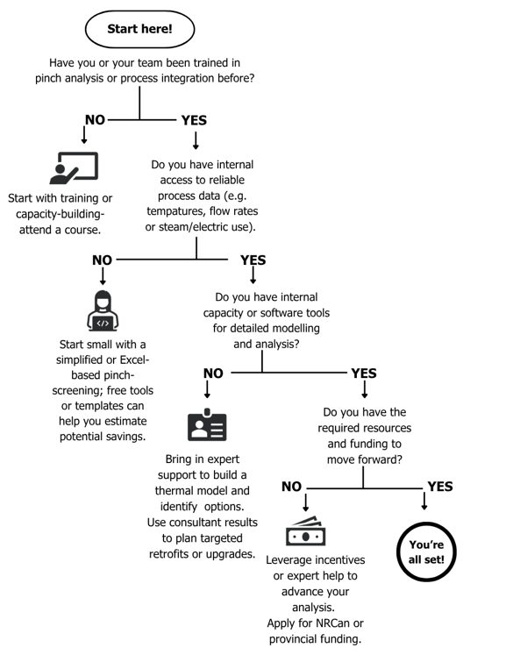

key Resources
Name | What it offers | Why it is useful for pinch analysis
Natural Resources Canada guide entitled: Pinch Analysis for the Efficient Use of Energy, Water and Hydrogen | A full-guide PDF with detailed explanations of the pinch method, composite curves and external heating (hot utility) and cooling (cold utility) source targeting. | Excellent foundational resource that helps understand the pinch method, terminology, the pinch principle and retrofit versus greenfield applications
NRCan’s “Process Integration and Pinch Analysis” page | An overview of process integration, the pinch method, when to apply it and typical savings | Helps determine candidacy and understand savings potential (10-35% range)
IESO/Save on Energy – Expanded Energy Management (EEM) Program (Ontario) | Ontario-based industrial program offering funding for energy management, training and support for facilities over certain thresholds | Provides financial incentives and support for industrial facilities to adopt structured energy management, which includes pinch screening and analysis
NRCan Energy Use Database | Large-scale data on Canadian industrial energy use by sector, fuel type and region | Industries in Ontario can compare their energy intensities, evaluate where they stand and whether pinch analysis would yield strong benefits
IPIECA Pinch Analysis (2022) – Energy Efficiency Compendium | A more recent industry compendium describing the pinch method, sectors, case studies and challenges | Global best practice, especially for complex facility case studies and validating applicability in heavy industry
Introduction to Pinch Technology | Document covering composite curves, the pinch principle and other concepts | Covers technology aspects and theory

Teams Instructions

Joining the Workshop
If you are not familiar with Teams, please see the following links for instructions on how to join. You can also join a test meeting by following these instructions to familiarize yourself with using Teams.
- How to join a Teams meeting (app or web)
- How to join a Teams meeting in Microsoft Teams (free version)
- How to join a Teams meeting without a Microsoft Teams account
- How to join a Teams meeting by phone

If you are having trouble connecting, please see the following resources on troubleshooting when you cannot join a Teams meeting.

TEAMs Features Used in this Workshop
Raise your hand  - At the top of your screen, click Raise.  - A hand should show up next to your name under Participants.  - To lower your hand, click Raise again.    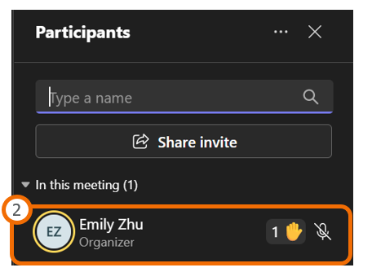 | use the chat to ask questions  - To use the chat, click Chat at the top of your screen.  - The chat should appear on the right side of your screen. Type your message in the message box.    


Joining a Breakout Room
When a breakout room is opened, you will see a button at the top of your screen labelled Join Room. Click the Join Room button to begin the breakout.

