Energy-Saving Opportunities IN THE fOOD & BEVERAGE Processing SECTOR
Participant Workbook
Use this workbook in conjunction with the “Energy-saving Opportunities in the Food and Beverage Sector” workshop to understand what is involved in achieving energy savings for your facility.

In this workshop, participants will:
- Understand different approaches to find energy-saving opportunities.
- Recognize energy waste that can lead to opportunities.
- Cement understanding of significant energy users at your facility.
- Identify 1-2 energy-saving opportunities you can implement at your facility.

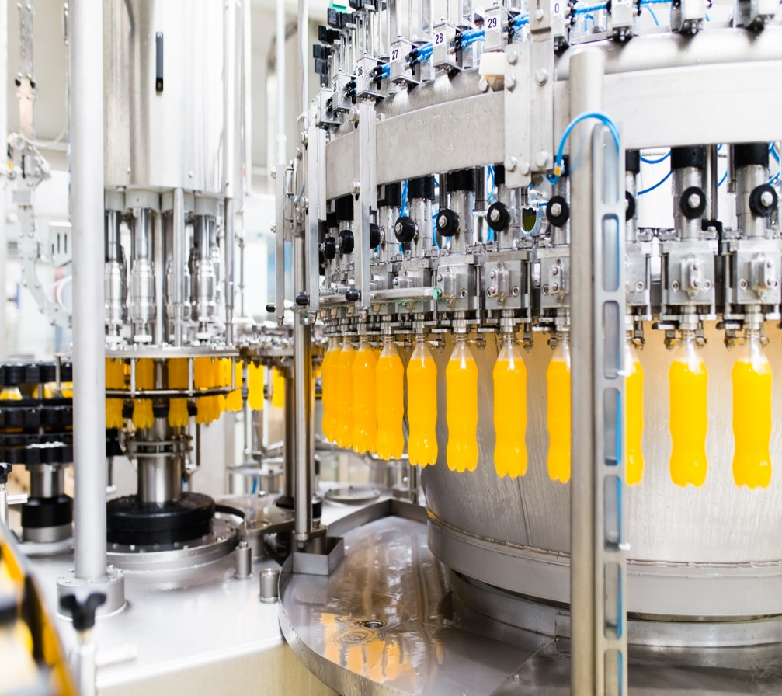

This workshop will be hosted over Microsoft Teams.
For support using Teams, see the last page of this workbook.

How do you find your energy-saving Opportunities?
The “how” of identifying savings opportunities can be divided into general practices and specific items.

General Energy Opportunity Identification practices
Check off or highlight the practices you currently use to identify energy-saving opportunities.
Data Analysis  - Energy Baseline Models  - Interval Data Analysis  - Energy Benchmarking | Site Investigation  - Energy Audits  - Energy Hunt  - Discussions with Operators | Employee Strategies  - Energy Training Sessions  - Suggestion Box  - Reviewing Capital Plans

In the space below, write down any practices to identify energy waste listed above or that were discussed in the workshop that you aren’t currently doing, and you would like to implement.

9 Type of Energy Wastes

Type of Waste | Examples of Opportunities | Opportunities within your Facility
Unnecessary Running or Idling | - Equipment and lights on during non-operating periods.  - Running pumps, conveyors or operating heat treat furnace at full temperature during idle periods
Leaks | - Compressed air leaks, uninsulated steam pipes, water valve leaks, broken duct work
Friction Loss | - Clogged filters, obstructed blower discharge, restricted flow due to damper settings, dirty heat and cold transfer services.
Sub-optimal Efficiency | - Replace existing equipment with higher efficiency models.  - Ensure proper installation of equipment and set to run at peak efficiency.
Malfunctions | - Broken or stuck actuators, valves and switches.  - Malfunction/broken equipment.  - Bearing failure.  - Broken or uncalibrated sensors and gauges.
System Imbalance | - Improper set points (overrides, bypass/manual)  - Simultaneous heating and cooling.  - Improperly programmed controls.  - Excessive water spillage.
Misapplication | - Improperly sized or ill-suited equipment.  - Compressed air used for open blowing, power tools, hand-held blowguns, vacuum generation.  - Compressed air used for personnel cooling
Underutilization | - Downtime, last minute changes, rush orders, running below peak efficiency, bottlenecks.  - Processes running below max capacity
Traditional Lean Waste | - Excessive material handling and excessive scrap or rework.  - Unnecessary waiting.  - Product over-processing.

Identifying your Significant Energy users
Knowing your large energy consumers is an important starting point for finding energy-efficiency opportunities.

Common Significant Energy Users in the Food and Beverage Sector
Common significant energy users can include:
- Refrigeration/Freezing  - Ovens/Baking  - Mixers/Grinders | - Cleaning Systems  - Pumps & Fans  - Compressed Air

List your top 3 significant energy users.
1)
2)
3)

Are you actively managing your significant energy users (SEUs)?
- We have identified our SEUs.
- We have identified variables affecting SEU energy consumption.
- We have identified people affecting SEU energy consumption.
- We submeter our SEUs.
- We have established energy-related key performance indicators (KPIs).
- We have developed standard procedures to ensure efficient operation of SEUs.
- We regularly monitor and report on SEU energy performance.
- We pursue corrective action when KPIs are outside acceptable ranges.

For more information on managing your SEUs please explore the following sections of the 50001 Ready Navigator:
- Task 9: Significant Energy Users
- Task 17: Operational Controls

Integrated Approach to Opportunities in Food & Beverage
Typical energy efficiency efforts focus on equipment that is commonly found in food & beverage processing facilities such as lighting, HVAC, compressed air, refrigeration, clean-in-place, and hot water.
However, looking at the equipment will only help you understand part of the problem. To fully understand the opportunity available, you need to understand how that equipment interacts with other systems.

The “WHY”
To most effectively address waste opportunities, you need to ask why it is occurring.
If you see waste occurring, it’s important to talk to the people who are familiar with the process and systems. Consider some of the following questions to help you get to the “why”:
- Why is the equipment operating the way it is?
- What would happen if the operation was changed to reduce energy consumption?
- What challenges are we using excess energy or resources to address?
- Could we change the conditions that generate those challenges in the first place?

Notes on Bruce Taylor’s (Enviro-Stewards) Presentation
Summarize other topics/issues, whether they are your significant energy users, general practices or specific techniques for finding new opportunities, or new potential energy-saving projects that you learned about today and want to act on in the near future.

Energy-Saving Opportunities
Thinking of the ideas and examples you’ve heard today, make a commitment to 3 actions you will take to improve energy performance at your facility.
Action | Timeframe
e.g. Investigate why water usage is so high in our CIP system | Next Week

Additional Resources
On the SEM Learning Platform:
- 9 Energy Waste Tracking Workbook
- Energy Hunt Tips and Tricks
Significant Energy Users:
- Overview of Food Processing equipment
Food and Beverage Opportunities:
- DOE list of Decarbonization projects
- DOE Energy-saving Opportunities in Food and Bev
- Checklist for Energy-saving Measures
- Enbridge Gas Foodservice Discount program

Teams Instructions

Joining the Workshop
If you are not familiar with Teams, please see the following links for instructions on how to join. You can also join a test meeting by following these instructions to familiarize yourself with using Teams.
- How to join a Teams meeting (app or web)
- How to join a Teams meeting in Microsoft Teams (free version)
- How to join a Teams meeting without a Microsoft Teams account
- How to join a Teams meeting by phone

If you are having trouble connecting, please see the following resources on troubleshooting when you can’t join a Teams meeting.

TEAMs Features Used in this Workshop
Raise your hand  - At the top of your screen, click Raise.  - A hand should show up next to your name under Participants.  - To lower your hand, click Raise again.    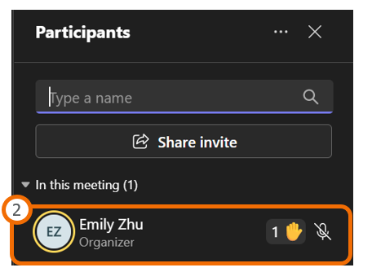 | use the chat to ask questions  - To use the chat, click Chat at the top of your screen.  - The chat should appear on the right side of your screen. Type your message in the message box.  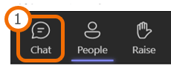  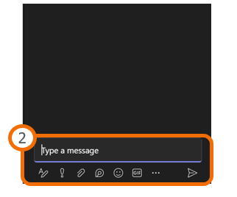

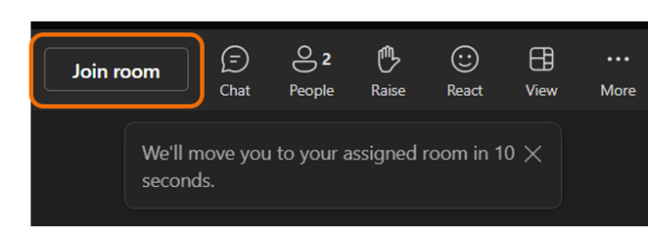
Joining a Breakout Room
When a breakout room is opened, you will see a button at the top of your screen labelled ‘Join Room’. Click the Join button to begin the breakout.

