

Many organizations see energy management information systems (EMIS) as large, high-cost projects that are difficult to justify without guaranteed savings. This workshop helps participants break that barrier by mapping their current situation, defining their desired end state and identifying practical gaps. Using these gaps, participants design a pathway toward EMIS adoption with a realistic entry point, one that demonstrates value and builds support for further investments.

This workshop also helps participants assess their current situation and their desired end state to identify gaps. Participants are then guided to use these gaps to assess what needs to be upgraded, connected or improved upon to achieve their desired end state. From there, they develop a practical path to achieve their goals along with a feasible entry point.

In this workshop, Participants learn to:
- Assess their current state and desired end state for EMIS adoption
- Identify key gaps and opportunities to move toward the desired end state
- Develop a practical pathway with a feasible entry point

FINDING THE RIGHT EMIS

ENTRY POINT
Participant Workbook
This workshop is hosted via Microsoft Teams.
For instructions or troubleshooting, please
see the last page of this workbook.

Why finding the right entry point matters

Many EMIS projects are faced with challenges in gaining internal approval because they are too large, costly, or complex. Starting small and aligning big reduce risk, demonstrate value, and build momentum for long-term success.

Case Comparison: Two EMIS Projects
Case A: full EMIS proposal  - High potential, high resistance  - Comprehensive EMIS design  - Full facility integration, dashboards, analytics  - Estimated cost: $500,000  - Projected savings: uncertain at proposal stage | Result  - Deferred pending clearer business case
Case B: submetering pilot  - Targeted loggers of significant energy users  - Investment: $10,000  - Manually collecting data | Result  - Quick approval  - Opportunity to build business case for further investment

Why Entry Points Matter
- Entry projects are low-risk proof of concepts.
- They demonstrate tangible results early.
- They build internal support and credibility.
- They are aligned with funding and incentive opportunities.
- They create momentum toward your full EMIS desired end state.
A full EMIS rollout is ideal when leadership is ready and confident in the value. When that is not the case, a well-chosen entry point project breaks through barriers and builds internal trust. Every successful EMIS project, whether launched big or small, starts by meeting the organization where it is. If your organization is ready, go all in. If not, choose an entry point that builds credibility and connects to your desired end state.

Mapping current state of your emis maturity
When mapping the current state of your EMIS, you want to consider the following four stages of EMIS maturity.
Stage | Description
Manual | Data are recorded manually — perhaps just a utility bill or meter check once a month
Partial | Some automation or submeters exist, but systems are not connected
Integrated | Systems share data across key energy uses and departments
Automated | Real-time dashboards and reports drive active decision-making

When considering your stage of maturity, consider all five aspects of an EMIS:
EMIS aspect | Description | Example
Metering | What is measured and where gaps exist | One main utility meter checked periodically
Data collection | How and how often data are gathered | Manual logs or spreadsheets
Analysis | How data are interpreted | Visual trend checks or bill comparisons
Reporting | How results are shared | Monthly summaries or emails
Communication | How insights drive action | Informal discussions with teams

Mapping your EMIS Path
Use this table to lay out your path from your current state to your desired end state. We will return to this table throughout the workshop.
EMIS aspect | Current state | Upgrade infrastructure | Connect systems | Improve processes | Desired end state
Metering
Data collection
Analysis
Reporting
Communication

Desired end-state vision

Your desired end state describes what success looks like for your organization. It helps ensure that your entry point and future improvements are aligned with and support the achievement of your desired end state.

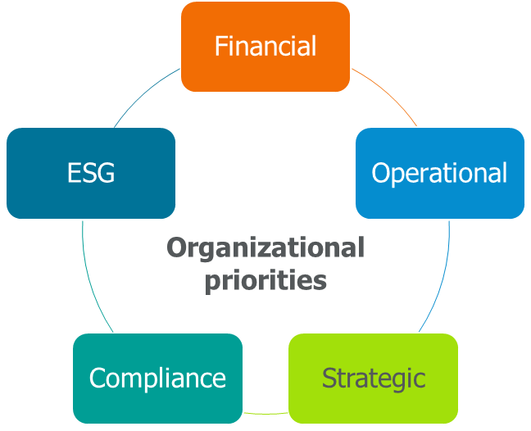
Your EMIS vision should support your organization’s priorities
Your desired end state should take into consideration:
- What features do you want?
- What impact should it have?
- How will it be aligned with organizational goals?

What does an EMIS vision look like in practice?
Here are some examples of what an EMIS vision looks like.
 | - Identify efficiency opportunities  - Improve reliability by supporting predictive maintenance  - Support ISO 50001 compliance
 | - Integrate with a building automation system (BAS) to maintain comfort  - Verify performance of efficiency measures like setbacks, occupancy controls, etc.  - Automatically report performance to management
 | - Track energy intensity of all buildings  - Support maintenance efforts  - Engage staff and students and integrate with academia

Example of current state and desired end state
Desired end states vary significantly from organization to organization depending on priorities, capabilities and the amount of energy consumption. Large facilities may have sophisticated desired end states, but for smaller facilities, the desired end state may be relatively basic because that is all that can be justified on a cost basis.
EMIS aspect | Current state | Desired end state
Metering | One main utility meter | Submeters on all major energy systems
Data collection | Monthly manual entry | Automated daily uploads
Analysis | Manual review of interval data | Automated analysis of performance metrics
Reporting | Ad-hoc Excel reports | Custom dashboards for all departments
Communication | Informal and inconsistent updates | Structured monthly review with recommended actions

Identifying and prioritizing EMIS gaps
Once you have identified your current state and desired end state, you can identify the gaps between those two states.

Three Types of EMIS Gaps
Gap type | What it means | Examples of how to address
Upgrade (infrastructure) | Missing or outdated physical or digital tools | Install submeters, upgrade servers, add sensors
Connect (systems) | Systems exist but do not communicate | Connect energy meters, BAS, production data, etc.
Improve (processes) | People or processes limit value | Improve reporting, tailor reporting to different audiences, ensure data visualization provides useful insights and supports desired actions

Visualizing gaps
Looking at what is needed to get from your current state to your desired end state helps you visualize the gaps that exist and that need to be addressed. Try adding these gaps into your assessment on page 3. An example of potential pathways to address gaps is provided below.
EMIS aspect | Upgrade infrastructure | Connect systems | Improve processes
Metering | Add submeters | Integrate meters with data gateway | Standardize naming conventions
Data collection | Add data loggers | Link data feeds to EMIS | Establish quality checks to prevent dropped data
Analysis | Use analytics software | Connect production data with energy data | Train staff in data analysis and interpretation
Reporting | Add dashboard capabilities | Automatically send reports to different audiences | Establish a reporting plan with defined processes and responsibilities
Communication | Establish channels to communicate insights and results | Improve communications across teams | Establish regular review and feedback sessions

Prioritizing which gaps to address first
Some gaps are easy wins while others require planning. Prioritization reduces risk and builds confidence. Clarity helps you focus resources where they matter most. Prioritizing your gaps helps define the scope of your entry point.
In the impact-effort matrix below, place gaps in the appropriate quadrant to help narrow down what your entry point should look like.

High | Good starting points | Later implementation phases
Impact | Potential starting points | Long-term options
Low | Effort | High

What makes a strong entry Point project
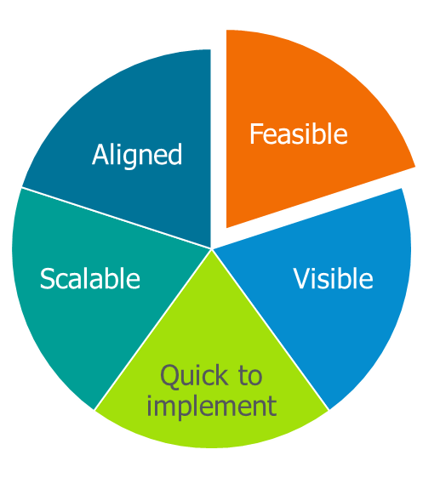
When thinking about which gaps to address and what components to include in your entry point, you should consider if it is:
- Feasible - low cost, realistic with existing resources
- Visible - results are tangible and easy to communicate
- Quick to implement - ideally completed within three to six months
- Scalable - builds directly toward your long-term EMIS vision
- Aligned - supports organizational and incentive goals

Write your idea below:
“My possible entry point project might be….”

How to Evaluate Potential Entry Point Projects
 | Yes | No
Can it be implemented with a limited budget?
Does it support existing priorities?
Does it build toward the desired end state?
Will it quickly deliver noticeable results?
Is it likely to get buy-in?

Leverage incentives to strengthen your case
Entry point projects may still qualify for EMIS incentives and cover submetering, data collection or integration activities. Documented savings from these incentives provide evidence to support further investments.
Under Save on Energy’s Expanded Energy Management Program, industrial facilities can receive funding of up to $250,000 for the installation of an EMIS.

Building Toward your desired End State
Your entry point and each subsequent step should move you closer to your desired end state. Hence, it is important to plan ahead to ensure consistent alignment and that aspects of your EMIS implemented early are still aligned and compatible with later additions.
Below are some tips related to each of the five aspects of an EMIS.
EMIS aspect | Tips to help futureproof your pathway
Metering | - Choose meters that support one or more open, widely supported communication protocols (e.g. Modbus TCP/IP, BACnet/IP, MQTT, HTTP/REST APIs, OPC UA):  - Pulse-output meters are connected using a logger or gateway that converts the pulses into a digital signal.  - Select meters with expandable/upgradeable features:  - Multiple parameters  - Upgradeable communications  - Onboard logging  - Standardize device naming
Data collection | - Design your communications backbone now:  - Ethernet is easy to scale and integrates easily with modern EMIS platforms.  - Plan for a central data-collection layer:  - Install a data acquisition system (DAS) or simple data gateway to act as a bridge between current meters and future EMIS and that stores data locally and forwards data to the cloud or future EMIS  - Coordinate early with your IT team:  - Use secure, segmented networks  - Plan firewall rules, VPN access, secure remote access for vendors  - Make sure existing IT infrastructure supports EMIS cybersecurity requirements  - Keep detailed records:  - Device models, serial numbers, firmware versions  - Network map and IP assignments, Modbus/BACnet register maps and point lists  - Data naming conventions
Analysis | - Store data locally (until cloud EMIS is chosen):  - Use a SQL database, time-series database or small-scale historian  - Choose consistent intervals (e.g. 15 second or 1 minute) and synchronize all devices via Network Time Protocol/UTC time stamps  - Archive raw interval data and aggregated data  - Collect all necessary data to achieve desired outcomes:  - E.g. additional parameters like kVA, power factors (PFs), harmonics, production data, BAS data, weather data  - Implement data quality flags
Reporting | - Set up standard reports for different audiences  - Develop reporting plans that detail audience, frequency, report format and responsible persons  - Avoid closed or proprietary systems
Communication | - Plan how insights will drive action  - Identify desired actions and the data and analysis needed to support them  - Get input from stakeholders on what would be useful to them as the system grows

Success factors for scaling
In addition to the above tips, there are some general success factors to keep in mind in the chosen path to your desired end state.
- Avoid closed or proprietary systems:
  - Proprietary systems lock you in and increase the risk of your current system not being compatible with your desired end state.
- Involve IT early:
  - Questions around security, compatibility and infrastructure should be addressed early on to avoid surprises down the road.
- Implement strong documentation and ownership:
  - Documenting, mapping and collecting specifications on meters and other system components as they are installed save significant time and money when integrating them into additional systems.
  - Strong ownership of the EMIS helps maintain the system and ensures progress will occur.
- Ask vendors about integration options early:
  - Inquire about potential features that will make future integration easier.
- Include future connectivity in your request for proposal (RFP) language:
  - When issuing RFPs, include specific language around ensuring future compatibility using standard protocols and the ability to modify or add system components as your EMIS grows.

Build Support as you Go
In addition to planning your EMIS path to be technically flexible and compatible to support growth, it is also important to take steps to ensure people in your organization support future investments. As you start to implement components of your EMIS, make sure you:
- Identify key decision-makers and champions who will get value out of the EMIS.
- Use simple visuals to communicate insights and progress of your EMIS journey to show its value.
- Tailor your messaging and insights so they are aligned with existing priorities.
- Celebrate the successes and benefits of your increasing data capabilities.

What is one specific action you’ll take in the next 30 days to move your EMIS forward?

