ESTIMATING HVAC PROJECT SAVINGS
Participant workbook
How do you know if an energy-saving opportunity is worth pursuing? After identifying an opportunity, you'll likely want to estimate the savings to evaluate if it's worth putting more effort and resources into it.
Understanding how to develop a reasonable estimate of energy savings can be very useful, but you need to know what tools or calculations to use, what assumptions are going into those estimates, and under what conditions they're valid.

In this workshop, participants will:
- Apply the four-step framework to estimate savings on HVAC projects.
- Identify areas where a different estimate approach is required depending
on applicability and available data.

- Gain expert insights to confidently address questions
and refine techniques for estimating savings.

This workshop will be hosted over
Teams.

Applying a framework for a structured approach
To ensure energy saving calculations are accurate and appropriate, a structured approach is critical for success. The following framework provides the basic steps in this approach:
- Assess available data – know that you have the right data to meet your required level of uncertainty.
- Gather equipment details and specifications.​
- Understand usage patterns​.
- Identify what is metered and how data is logged.

- Establish a baseline – understand the total energy use to know that savings estimates are in the right ballpark.
- Estimate or measure the total energy consumption​.
- Understand energy consumption over different seasons, production schedules and types of operation​.
- Consider runtime, duty cycle and partial loads.

- Understand the savings mechanisms – know how your system reacts to changes to avoid incorrect assumptions in estimates.
- Understand how changes to the system affect how equipment works and how those changes can lead to energy savings​.
- Avoid under-or over-estimation by ​ensuring the estimated savings reflect how the equipment is actually operated.

- Calculate savings – choose the right calculations or rules of thumb.
- Apply rules of thumb, tools, or calculations to estimate project energy savings.
- Apply your understanding of savings mechanisms to ensure you aren’t using calculations that don’t include assumptions that don’t apply to your system.
- Compare savings estimates to baseline annual energy consumption to check for reasonableness.

Step 1: Assess available data
The first step in the framework is to assess all available data. Since energy-saving opportunities are often trade-offs between how much energy is used in different components, it’s important to take a systems approach when gathering available data that includes:
- Gathering equipment details and specifications
- Control sequences or control logic
- Understand usage patterns
- Establish the facility’s requirements
- Identify what is metered and how data is logged
To evaluate HVAC opportunities, you will need to have some of the specifications for the equipment such as:
- Motor size (hp)
- Pump flow, head
- Fan flow, static pressure
- Operating conditions
A good start is to validate what already exists, create equipment or asset lists, review existing plans and previous energy studies. Consider your system of interest. What equipment specifications data might you already have? Where might you find more information on your current system?

Ideally, look for:
- Nameplate information
- Type of system
- How is it controlled (and where)
- Condition of unit and known issues
  - Talk to personal both operations and maintenance and on the production floor
Usefulness of data on nameplates varies depending on the system:
- For motor-driven systems look for:
  - Motor hp, efficiency, power factor
  - Driven system nameplate- flow, pressure, etc.
- For heating and cooling equipment look for:
  - Capacity (kW, BTU/h, Tons, etc.)
  - Nameplate efficiency
  - Flow (air, water)
  - Modulation capacity
Do you have an idea already of what type of system you have, how and where it is controlled or it’s current condition? Who might you talk to about this to get more information?

A useful diagnostic equation
This equation allows verification that dampers and temperature sensors on the BAS are coherent with one-another.
It should be used when outdoor temperature is quite different than return temperature:
% O$utside Air=\frac{ (Treturn - Tmixt)}{(Treturn -Toutside)}$

Considering building envelope measures
If building envelope measures are under consideration or measures targeting a reduction in space heating or cooling, data on the envelope must be collected:
- Wall, roof, door (incl. overhead) areas
- Estimated R-values of opaque components
- Type of windows (double, clear or tinted)

IMPORTANT TO NOTE!
R-values are often difficult to obtain, especially for walls so a typical value must often be used, such as:
- R-5 for pre-1970 building, R-10 for pre-1980 and R-15 for more recent
- Roof values are typically known as re-roofing is common

Step 2: Establish a baseline
The second step in the framework is establishing an accurate baseline of energy consumption. In this step, you will estimate or measure the total energy consumption, capturing the variations over different seasons, production schedules and changes in operations.
For this step you will need to:
- Estimate or measure the total energy consumption
- Understand energy consumption over different seasons, production schedules and types of operation
Remember, you cannot save more than the current baseline for a given end-use or equipment

Building a load inventory
To establish an accurate baseline, use the data collected in step 1 to build a load inventory. This inventory provides the energy and demand baseline of all your systems. Keep in mind that, while the inventory applies to all HVAC equipment, it will often capture all energy-using equipment.
The load inventory will then be used as a basis for savings estimates. Once the inventory is established, different approaches can be used to establish a baseline:
Method of estimation | What it entails
Simple load method | Simple calculations using values such as unit load, total kW, hours of use per period, etc.
Motor load method | Using calculations based on values such as motor hp, motor load % and motor efficiency %
Current-voltage method | Using calculations based on values such as the number of units in operation, line voltage for the load, current drawn by the load, etc.

Simple load method
The following table provides an example of the type of data required for simple load calculations:
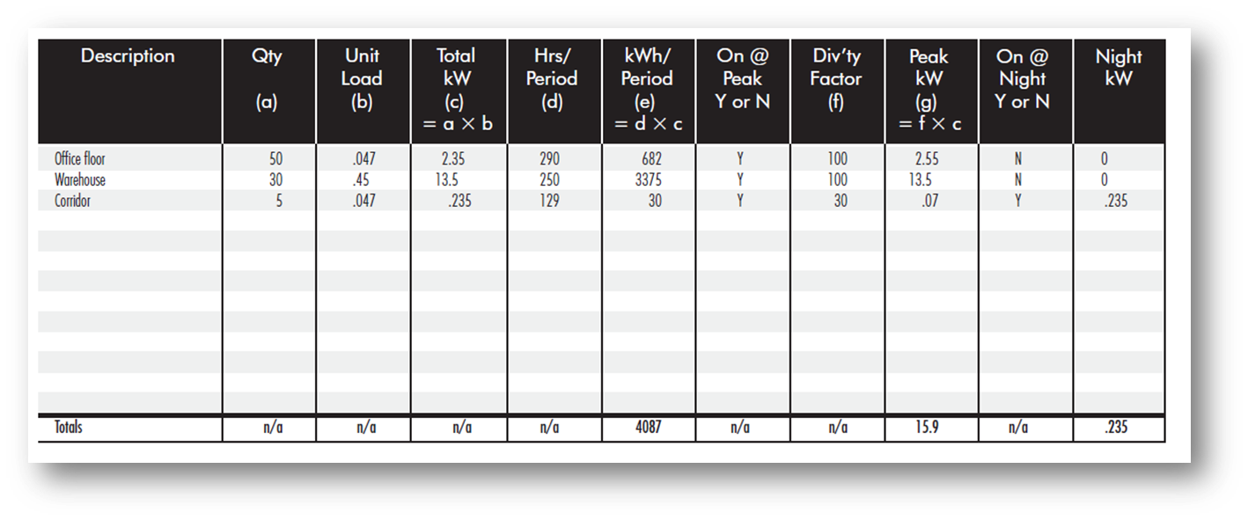
Note the hours must account for load factor and cycling of equipment (e.g. compressors running on/off or part load) – often called Equivalent Full Load Hours (EFLH).
This data can them be used for the load calculations shown below:
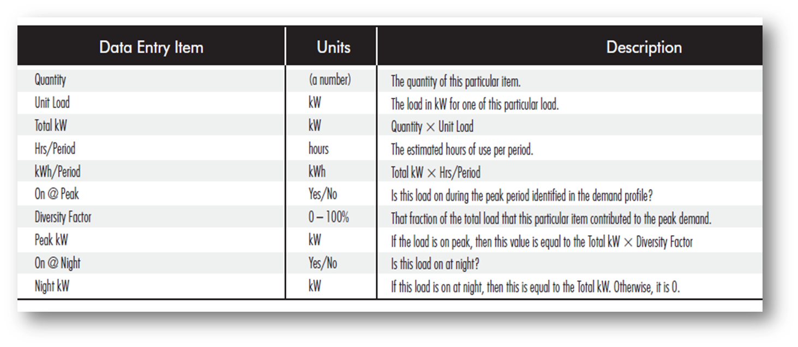

Motor load method
The data shown below provides an example of the motor load method.
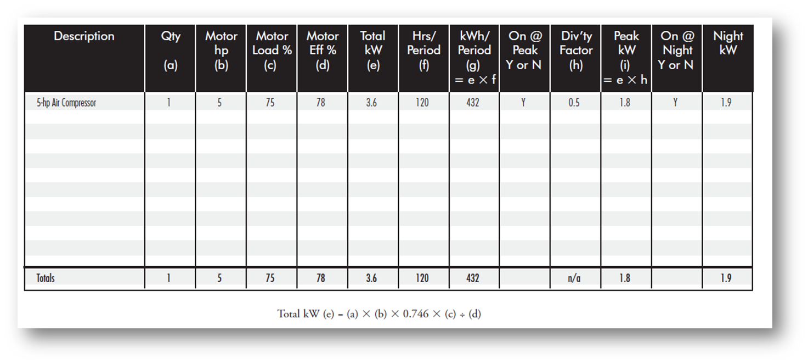
When using the motor load method, it is important to consider how the data you have gathered applies to how the motor is operated in your system. The following table provides some of these considerations.
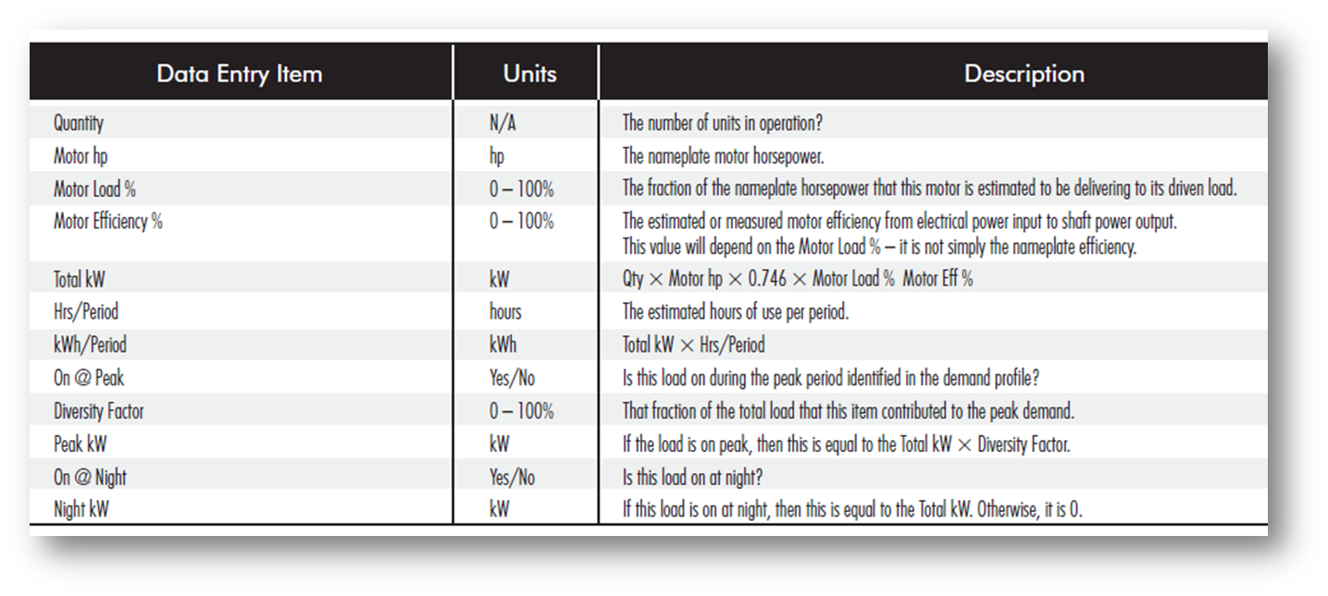

Current-voltage method
The table below provide an example of load calculations using the current-volage method.
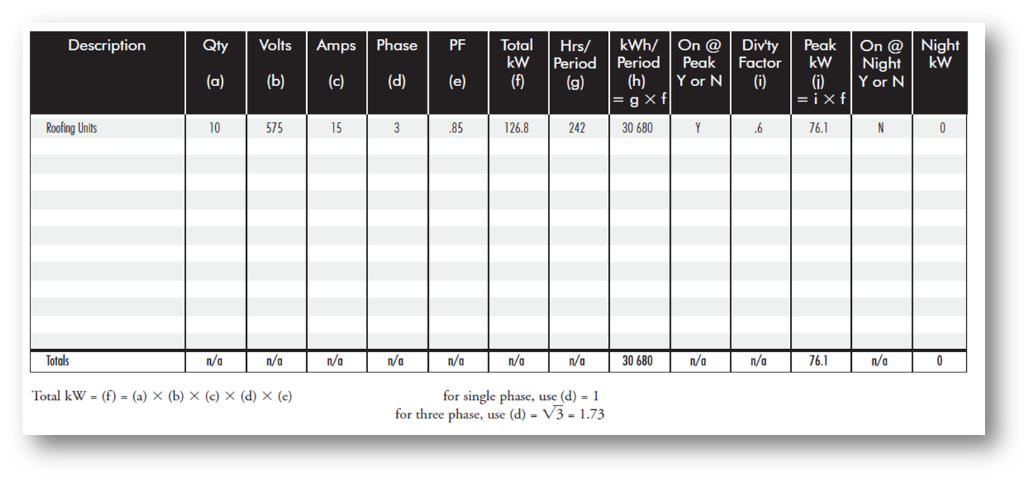
For the current-voltage method, refer to the table below additional considerations regarding your data.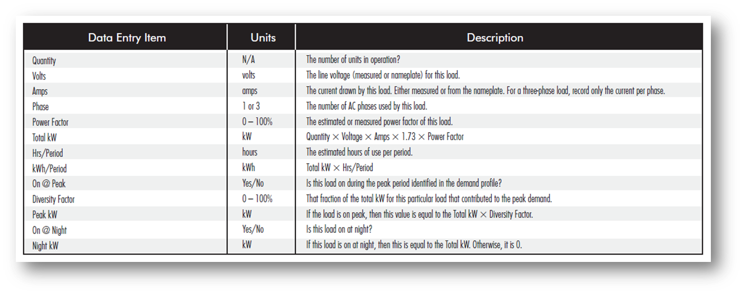

Baselining heating load: makeup air units & single zone systems
For calculations involving makeup air units and single zone systems:
Q = CV1 * Outdoor Air Flow * HDD * 24 / Efficiency
- Where CV1 = 1.08 for flow in CFM and .0012 for flow in L/s
- HDD = heating degree-days at the average supply air temperature
- Results are in BTU/hr for CFM and kWh for L/s
This equation is based on HDDs and the results will be for the period over which the HDDs are calculated, often yearly.

Baselining heating load: multiple zone & mixed air units
For multiple zone mixed air unit (cold deck such as VAV systems) you need to evaluate the outdoor temperature below which the system will require heating of the mixed air:
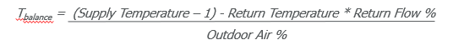

Then obtain the HDDs for the Balance Temperature (RETScreen, DegreeDays.net, and other resources to obtain the HDDs) and apply the previous equation to obtain your heating load.

Baselining cooling load from ventilation
Use the same approach as for heating using cooling-degree days (CDDs) instead of HDDs. In this case, the results are for the sensible load only as this approach excludes dehumidification. Cold deck systems can be treated just like single zone systems.
If the latent load is to be included:
- Either use the enthalpy equation, much more complex
- Use a very high-level estimate replacing CV1 from 1.08 to 1.5 in IP units

Baselining heating/cooling load from building envelope
These involve complex calculations that are typically not done manually. For these calculations, one of the fastest methods to obtain a high-level estimation is to use a computer-based tool, such as RETScreen. For this method, use collected envelope data to populate the tool.

Reconciling Inventory to Measured Values
When reconciling inventory, remember that:
- Reconciliation should be done for summer, winter and shoulder periods respectively.
- Reconciliation should be done for energy (kWh) and peak demand (kW).
- You should adjust the least known parameter, almost always the estimated diversity for demand and operating periods (or full-load hours) for energy.

Common baselining errors and omissions
- Over or under-estimating the operational period of the equipment
- Not considering the load factor on the equipment
- Not considering the cyclic operation, or part-load operation, of an equipment
- Poor estimation of the amount of outside air or exhaust air from your facility
- Poor estimation of the diversity factors

What approach do you typically use in estimating your baseline consumption for HVAC?

Outcome of step 2: Establish a baseline
By establishing a baseline, you will:
- Develop an understanding of the total energy consumption of the system across all mode of operation is developed
- Uncover errors in savings estimates that become obvious when seen as an unreasonable percentage of total consumption
An accurate baseline provides guardrails to keep savings estimates on track.

Step 3: Understanding the savings mechanism
The third step in the framework is understanding the savings mechanism. It is important to understand how changes to the system affect how equipment works and the savings potential. To do this, ensure the estimate is based on how the equipment is operated and verify that the estimated savings reflect reality.

HVAC savings mechanisms
HVAC measures produce savings through three main mechanisms:
- Reducing he hours of operation
- Reducing the loads on the systems
- Improving the systems efficiencies

The biggest opportunities are the simplest:
- Scheduling and optimal start
- Proper operation of dampers
- Bring in only as much outside air as is needed
- Unoccupied mode shutdown/restart mode
- Heat recovery control

You can achieve the best performance from existing systems with some of the following tips:
- Running pumps in parallel is rarely optimal, even with VFDs
- High efficiency chillers are often better at part load and
should be run in parallel when possible
- Condensing boilers are often better at part load and
should be run in parallel when possible
- Cooling towers with more than a single cell should be run in parallel when VFDs or two speed motors are used, not lead/lag
- VFDs always at 100% (or close to) are inefficiently utilized and the control sequence need to be revised
- Installing a Building Automation System for the HVAC

Common Errors in assumptions about savings
- Reducing outdoor air intake results in systematic savings
- Installing VFDs on motors will result in savings...only if there is a working control system actively modulating the VFDs or the systems were over-sized.
- Adding a BAS to the HVAC system will result in systematic savings.
- Speed modulation uses the affinity laws for most HVAC systems, motor savings are not proportional to speed modulation.

Outcome of step 3: understandng the savings mechanisms
By understanding savings mechanisms, you will:
- Have established a list of potential energy and demand savings measures for your various HVAC systems.
- Have a good understanding of the impact of the measures both on energy and demand for your facility.

What savings mechanisms do the efficiency opportunities you identified make use of?

Step 4: Calculating the savings
The fourth step in the framework is to calculate the savings. At a high-level, this step can be summarized in the statement below:
Energy Savings = Adjusted Baseline – Reporting Period +/- Non-Routine Adjustments

What does calculating savings include?
- Rules of thumb
- Engineering calculations
- Complext modelling
- Utilizing the baseline evaluation methods as much as possible!

Calculating motor savings
Use the equipment inventory:
- For scheduling change, only modify the hours (EFLH) of operation
- For changes inplacting the motor load, typically installing a VFD, a change to the load factor is requires and this change must consider the affinity laws:
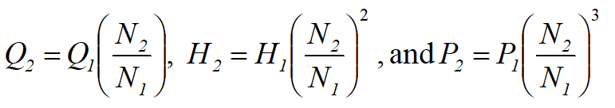
Where:
N = Fan or Pump speed, typically in revolutions per minute
Q = Flow, typically in CFM, L/s, m³/h or gpm
H = Head, typically in metres or feet water column for pumps and Pa or in w.g. for fans
P = Power in kW or BHP

- Therefore, a 10% reduction in speed will yield at 27% reduction in power!
- This applies to fans and pumps (centrifugal equipment)

Calculating ventilation heating and cooling savings
Using the baseline equation:

- Consider any change in flow as well as in schedule
- Use the power equation provided to estimate the actual percentage of outside air, not just the damper setting.
- Always consider any change in supply temperature set point
  - For single zone systems, use the space temperature set point as the supply temperature set point
  - The balance point for multizone system sometimes needs to be revised due to a change in outdoor air flow and supply temperature set point.

Destratification and envelope savings
For building envelope:
- Directly modify the insulation values (R-values)
- Change in set points, including night set backs, are directly calculated
For destratification:
- Modify the set point for the zone where the roof is located but not for all the walls, often requires defining the roof separately
- To include exfiltration credit, same approach is needed, define the infiltration with the roof or separately so that the remaining Envelope components are not impacted by the change in temperature

Equipment sequencing and high efficiency equipment
For the space heating component, from the building envelope:
- Use the computer-based tool and modify the average yearly efficiency but be careful of overestimating the improvement.
And for ventilation units:
- Use the baselining equation and replace the average yearly efficiency by the new estimate.
- For exhaust air heat recovery, multiply the resulting consumption by (1-Effectiveness), with the effectiveness being reduced by about 10% to go from nominal to yearly (high level estimate).
What energy savings calculations are available for your HVAC systems?

Conclusion
The final output of the framework is a defensible and repeatable analysis that can be used to prove project savings to evaluators and internal stakeholders.
By employing the systematic approach provided by the four-step framework, you can be confident that your savings estimates are grounded.
Additionally, you can avoid inaccurate estimates that put your reputation at risk and question the value of energy efficiency initiatives.
Finally, a reminder that ongoing data logging, measurement and verification activities will ensure that the energy savings persist in the future.

Additional Resources
- Training Modules by Technology Area | Building Science Education
- HRAI Whitepapers
- NRCAN: Energy efficiency for industry
- USDOE: Better Buildings Solution Center | Better Buildings Initiative
- USDOE: MEASUR Tool Suite (includes psychrometric calculator, weather binning calculator, etc.)
- Home | ashrae.org
- Heating, Ventilation, and Air Conditioning Projects | Department of Energy

Questions and Answers

Notes:
_____________________________________________________________________
_____________________________________________________________________
_____________________________________________________________________
_____________________________________________________________________
_____________________________________________________________________
_____________________________________________________________________
_____________________________________________________________________
_____________________________________________________________________
_____________________________________________________________________

