ESTIMATING COMPRESSED AIR PROJECT SAVINGS
Participant handout
How do you know if an energy-saving opportunity is worth pursuing? After identifying an opportunity, you'll likely want to estimate the savings to evaluate if it's worth putting more effort and resources into it.
Understanding how to develop a reasonable estimate of energy savings with limited information can be very useful, but it's also important to understand what tools or calculations to use, what assumptions are going into those estimates, and under what conditions they're valid.

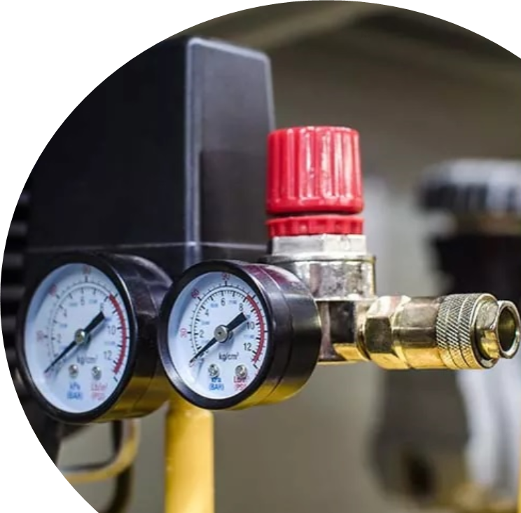
In this workshop, participants will:
- Learn how to estimate energy savings from compressed air projects.
- Understand when to apply different estimation approaches depending on applicability and available data.
- Have questions about estimating savings answered by compressed air expert Ron Marshall.

This workshop will be hosted over Teams.

Compressed Air System FundAmentals
For an effective and efficient overview of compressed air fundamentals we highly recommend the Introduction to compressed air optimization course on the Energy Management Learning Platform.
While it isn’t the objective of this workshop to cover the fundamentals of compressed air systems in depth, there are several key concepts to keep in mind when estimating project savings:
- Understanding the components of compressed air systems.
- Compressor types and control characteristics.

Components of Compressed Air systems
Compressed air systems can be broken down into supply side and demand side components. Supply side components are responsible for generating and conditioning compressed air while the supply side components distribute and make use of compressed air.
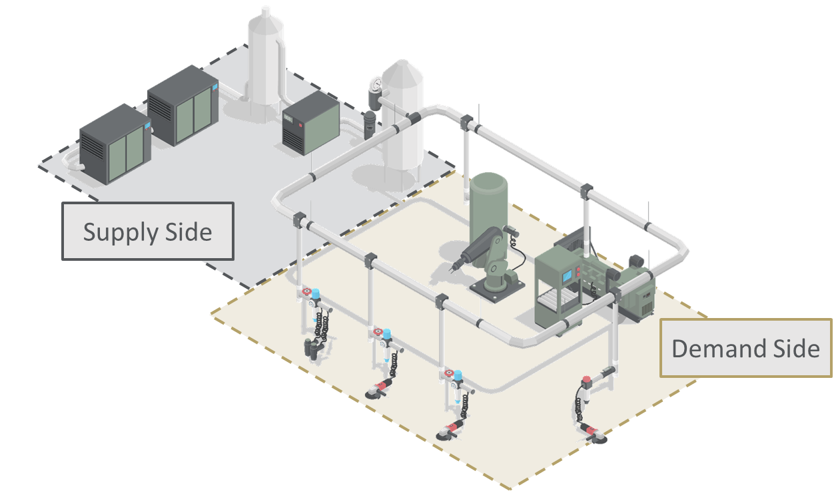
Figure 1: Compressed air system divided into supply and demand side.

Supply Side COmponents
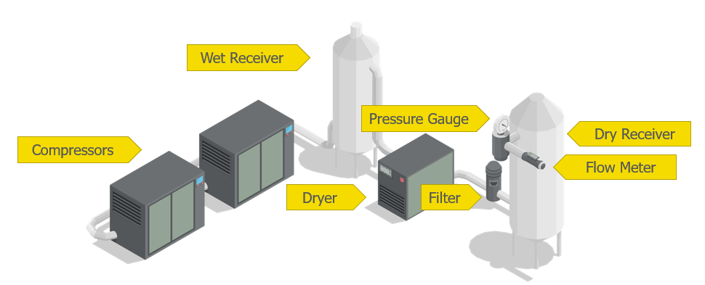
Figure 2: Typical compressed air system supply side components.
Compressors: Increase air pressure to a defined setpoint. There are multiple different types of compressors and large systems often utilize multiple compressors simultaneously.
Wet receiver: A storage tank located between the compressors and the air dryer. Allows moisture to condense out of the air. The wet receiver also acts to modulate pressure changes to improve compressor control.
Dryer: Remove moisture from compressed air. Several different types of dryers are available including refrigerant, desiccant, specialty gas/liquid dryers, membrane dryers, and deliquescent dryers.
Filter: Prevents any moisture or contaminants from entering the dry receiver.
Dry receiver: A storage tank located between the dryer and the supply side distribution system. Acts as a buffer which ensures a consistent flow and pressure for both supply system and the dryer.
Pressure gauge: Displays pressure and may be used to monitor and collect trend data.
Flow meter: Displays the amount of compressed air flowing through the system. May be used to monitor and collect trend data.

Demand Side Components
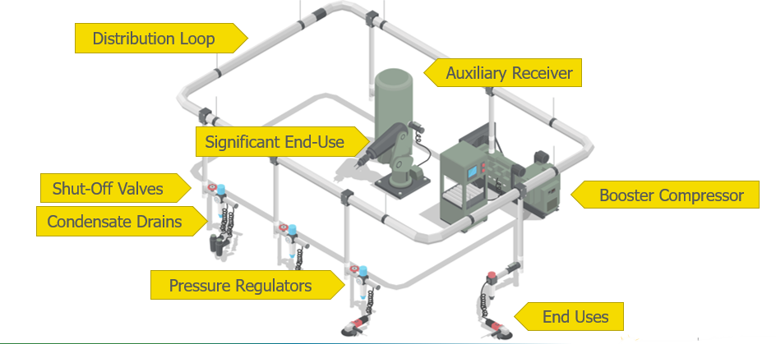
Figure 3: Typical compressed air system demand side components.
Distribution loop: Distributed the compressed air from storage to where it is needed for end uses.
Auxiliary receiver: Can be placed between the distribution line and significant air users to reduce the impact their use has on system flow and pressure.
Significant end-use: An end-use with greater demands on the system than typical equipment. This could be higher pressure or flow requirements or stricter requirements around moisture or contaminants.
Booster compressor: Used to increase supply pressure for significant end-uses that require abnormally high pressure.
Shutoff valves: Installed throughout the compressed air distribution system to isolate sections when compressed air is not needed.
Condensate drains: Ensure that condensate does not accumulate in one area leading to reabsorption into the air or flooding a piece of equipment.
Pressure regulators: Control the air pressure delivered to an end-use. They keep equipment from being over-pressurized and reduce excess flow through openings.
End uses: Can include motors, pumps, controls and actuators, cooling, spraying, mixing, vacuums, hand tools, and others (including inappropriate or unregulated uses).

Compressor Types and control characteristics
There are several types of compressors, and several types of control strategy for operation. Each has performance trade-offs and understanding these characteristics is vital for optimizing a compressed air system.

Types of Compressors
Compressors can generally be grouped into two categories: positive displacement compressors which draw air into a chamber and then force it to exit an outlet at a higher pressure, and dynamic compressors which impart energy into the air from rotating impellers. Compressors can be single stage, or multi-stage to achieve higher compression.
For more information on the different types of compressors, refer to:
- Natural Resources Canada: Air Compressor Types and Controls

Compressor Control Strategies
Compressors can be operated by different control strategies to optimize varying aspects of compressor performance. Each control strategy may not be applicable for every compressor type. These control strategies will influence how your compressor responds to changes in flow or pressure so understanding that relationship is critical to accurately estimating savings.
For more information on different types of compressor control strategies refer to:
- Natural Resources Canada: Air Compressor Types and Controls
- Compressed Air Challenge: Fact Sheet #6: Compressed Air System Controls
- Compressed Air Best Practices: Compressed Air Controls
How are the air compressors in your compressed air system controlled?
Individual compressor control strategies  - Start/stop  - Load/unload  - Modulating  - Multi-step (part-load)  - Variable frequency drives | System controls  - Sequencing controls  - Network controls

Compressor Characteristic Curves
A compressor control curve illustrates the relationship between the power input into a compressor and the capacity at which the compressor runs. As illustrated below, most control systems run efficiently near full load and offer widely varying levels of performance at low load. Picking the right compressor control system for your application should consider how you expect your system to operate to maximize its efficiency.
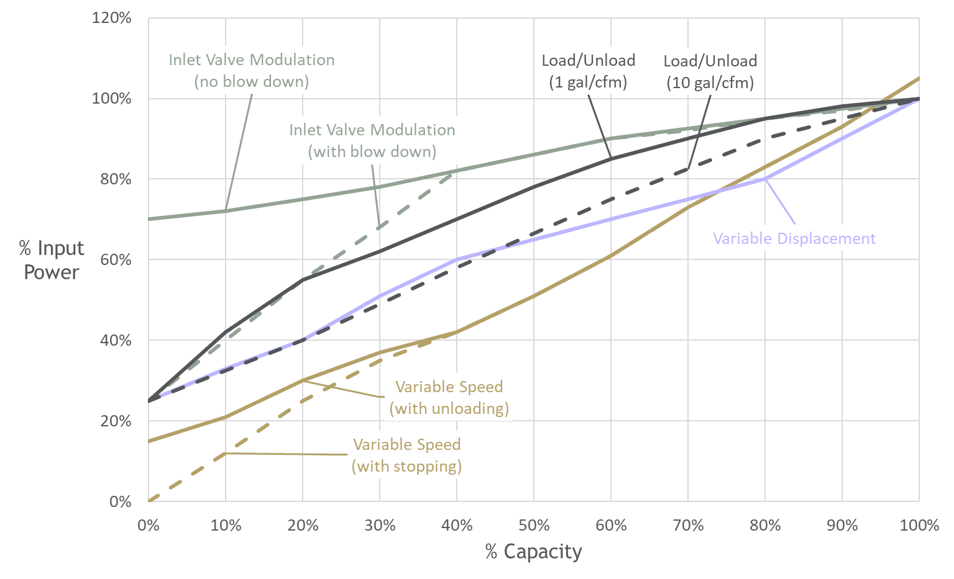
Figure 4: Typical compressor capacity curves by control type.

Additional Resources
- Compressed Air Challenge Online Library
- Compressed Air Challenge - Improving Compressed Air System Performance
- DOE - Compresses Air Systems
- DOE - MEASUR Tool

Developing Compressed Air Baselines
Many packaged compressors are equipped with instrumentation that provide reasonably reliable pressure, power, amps, % load, flow, or % capacity outputs that can be read in real-time on a display screen or logged for access to longer-duration continuous data. The following methods are intended to help in cases where you don’t have access to ideal data.

Power Calculations
The most reliable way to determine electrical power (P_{e}) is to measure three-phase power, but when that’s not possible there are a few options, with varying degrees of accuracy.

Nameplate Method
If you’ve got nothing but the motor nameplate and just need a rough estimate, you can start here:
$${\text{P}}_{\text{e}}\text{ =}\frac{{\text{ hp}}_{\text{nameplate}}\text{ × 0.746 [kW/hp] × Load Factor }}{\text{η}\text{motor}}$$
Where load factor (LF) can be your best estimate between 0% - 100%
- Keep in mind that most equipment is overdesigned (i.e., includes a “capacity factor”).
- The better you know the equipment in your facility (e.g., metering of similar systems), the better your estimates will be.
- See below for more notes on load factor and duty cycle.

Calculating Power from Current (Amps)
Moving up in order of accuracy, amp measurements can be a good substitute for power.
To calculate three-phase power from amps, use the following equation:
$$\text{P}\text{e}\text{ =}\frac{\text{V × I × PF × }\sqrt{\text{3}}}{\text{1000}}$$
Where:
P_{e} = Three-phase power [kW]
V = RMS voltage, mean line-to-line of 3 phases [V]
I = RMS current, mean of 3 phases [A]
PF = Power factor as a decimal [-]
Or use the percent of full load amps (FLA) method:
The amperage draw of a motor varies approximately linearly with respect to load (power), down to about 50% of full load. Below the 50%-point, power factor degrades, the amperage/power curve becomes increasingly non-linear, and amp measurements are not a reliable indicator of load. Use the three-phase power equation in these cases and see the power factor notes and references below.

Notes AND References
Power factor: for typical power factor v. motor load by motor sizing, see Figure 4.5 (page 63) of the US Department of Energy’s (DOE) Premium Efficiency Motor Selection And Application Guide

Estimating Air Flow Using Characteristic Curves & Cagi Sheets
The following steps provide a process for estimating flow from a power measurement, using Compressed Air and Gas Institute (CAGI) data sheets or compressor characteristic curves, or the reverse.
- Look up the CAGI data sheet for your compressor.
- Use your compressor power estimate and the total package input power to calculate the % input power, adjusted for the actual discharge pressure on the basis of 2 psi = 1% power.
  - Compressor specific power can also be calculated at varying discharge pressures using isentropic efficiency. Reference CAGI for more details.
- Then use the % input power to interpolate the operating capacity %, based on control type, from a reliable characteristic curve – ideally for the specific compressor model, or create your own curve using the CAGI sheet data (e.g., total package input power and input power at zero flow).
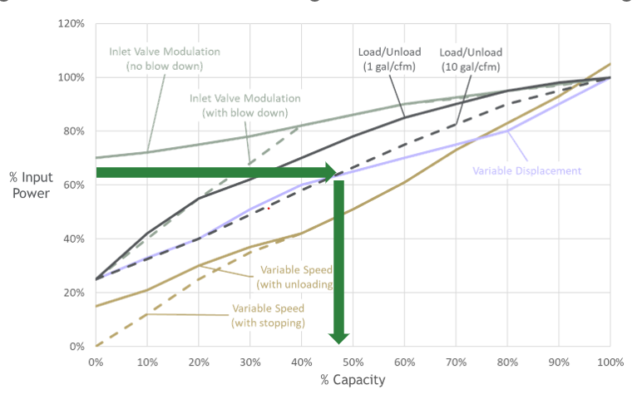
Figure 5: Interpolating input power using the compressor capacity curve.
- Then, estimated flow = (capacity %)$×($rated capacity)  - Alternatively, if you have a flow measurement (or % capacity), but are unsure about power, you can reverse this process to estimate power and/or validate your calculation (e.g., from amps). | 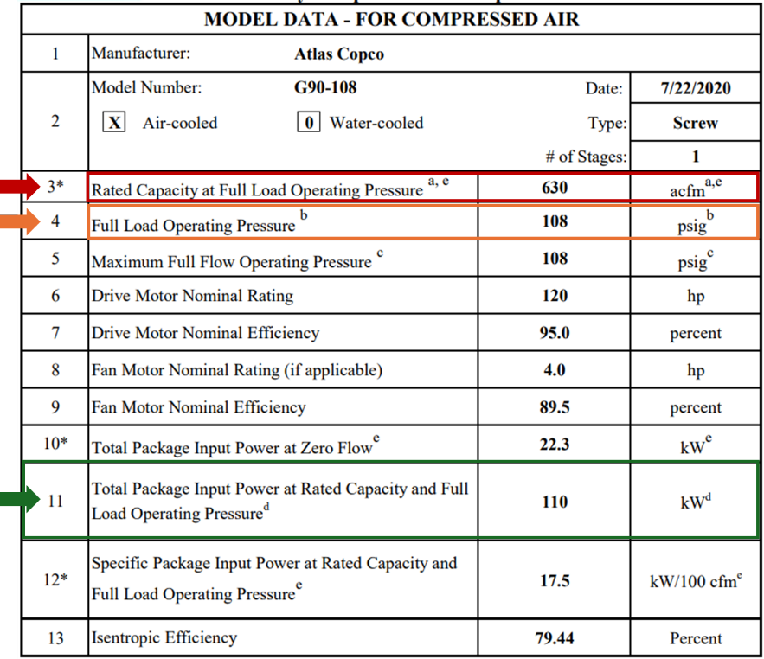  Figure 6: Typical CAGI sheet with key parameters highlighted.

Operating Hours AND Developing An Annual Baseline
After making the effort to come up with accurate power and flow estimates, be careful when transforming your estimates into a baseline. To accurately add the element of time, you must consider load factor and duty cycle.
The use of compressed air systems will vary throughout each day, week, and even year. Getting an accurate understanding of usage patterns is invaluable for determining an accurate baseline. Operating hours will have a major impact on compressed air usage so accurately tracking factors such as seasonal variations, plant shutdowns, or holidays is required to from an accurate baseline. It is worth noting that while tracking operating hours is important, compressed air usage may not align precisely with operations as leaving compressors on for leakage levels will skew your data.
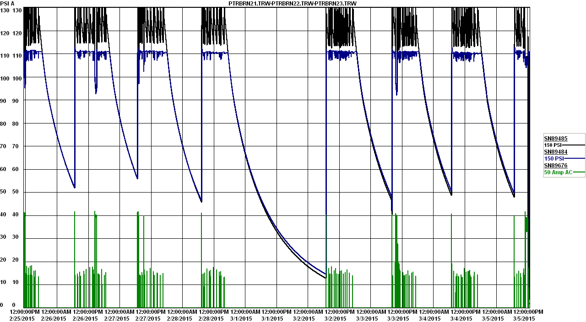
Figure 7: Logged pressure data illustrating compressor run time.
A baseline should be constructed from data that is fully representative of use within a facility and therefore should, in a best case, include data from a continuous period of at least 12 months. This ensures that any seasonal variations or changes in production are accounted for.

Load Factor
Depending on how your compressor is controlled, it may experience varying degrees of loading. Load data can generally be accessed from the compressor status logs. Once load data has been determined, power can be estimated using a representative compressor characteristic curve.
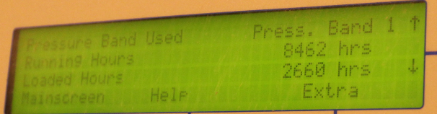
Figure 8: Compressor display screen showing loaded/unloaded hours.

Duty Cycle
The duty cycle of a compressor can also generally be determined by data procured from the compressor status logs. Total operating hours and load/unload status will allow you to calculate the duty cycle of a compressor. If compressor status logs are not available, consider manually timing the system modes for as long as necessary to be sure you have captured a representative sample of cycles.
Load-duration plots like the one pictured below are a useful tool for visualizing the load factor and duty duration of a compressor system.
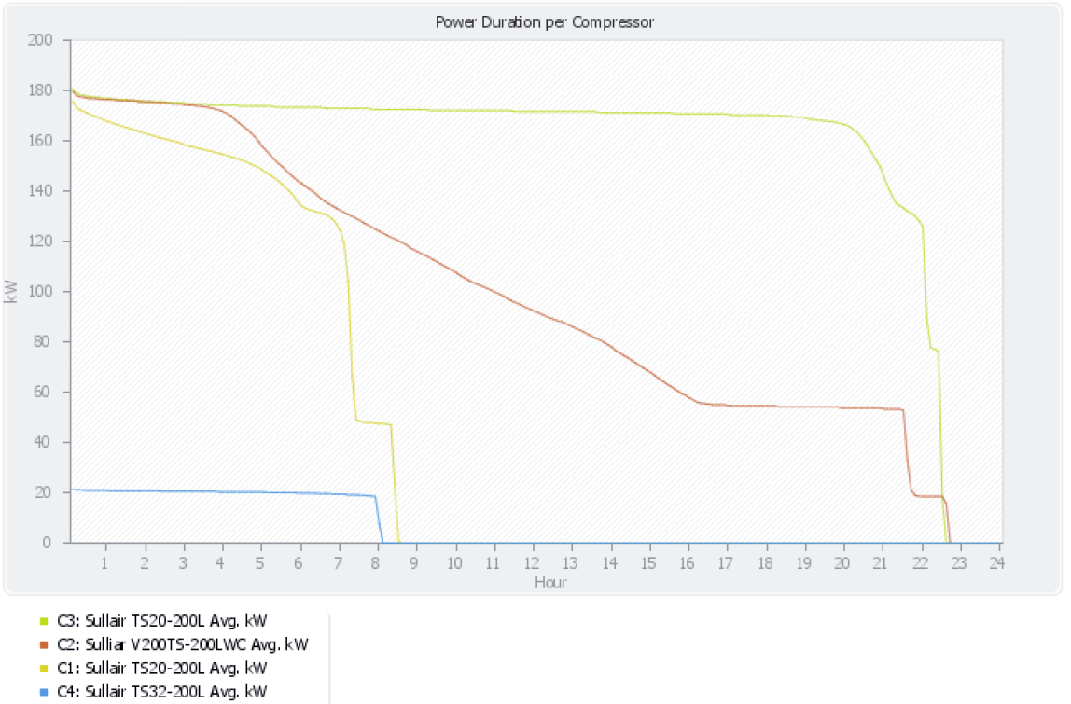
Figure 9: Air compressor load-duration plot.

Estimating SAvings
Estimating savings starts with your baseline, as described by these two approaches:
- Estimate the post-project power and energy consumption along the same methods described above. E.g.: if you are introducing a more efficient compressor, use CAGI sheets and characteristic curves to develop new power estimates and combine that with what you’ve determined for the load factor and duty cycle to estimate the post project energy consumption.
  - Take the difference of the baseline and the post project energy consumption to get the estimated energy savings.
- In some cases, it may be appropriate to estimate savings directly from the energy baseline. E.g.: Reducing compressor discharge pressure (see below) or reducing air flow demand by 10% (see below).
  - Apply appropriate savings factor (e.g., 1% of baseline power for every 2 psi pressure reduction, or the effective kW/100 cfm for flow reductions)
Examples of how these principles can be applied to various types of compressed air energy-savings projects are provided below.

Flow Reduction – Leak Repair
Savings mechanisms: Reduced air flow demand reduces air production and therefore reduces input power.  Calculation methods: Flow measurement during non-production, Db measurement (inaccurate), pressure drawdown, cycle timing test for load/unload  Calculation pitfalls: Poorly controlled systems don’t react precisely to flow reductions. | 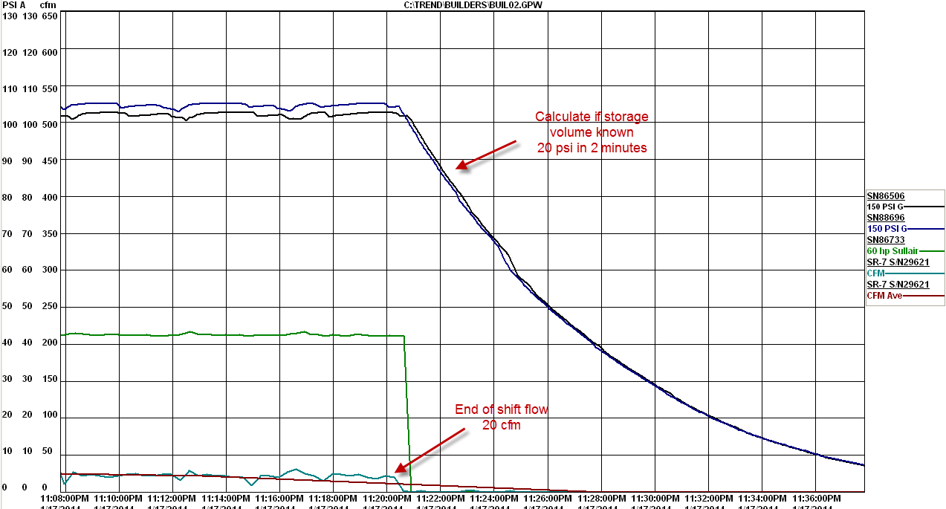  Figure 10: Logged pressure data showing system pressure decreasing after compressor stops.
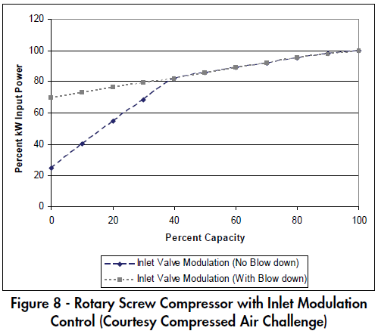
Example calculation:
Modulating compressor system at an average of 2,000 cfm and 450kW
Estimated leak rate: 250 cfm, per cycle timing test
Assume you fix 80% of leaks → 200 cfm
Typical compressor loading between 85-100%
Per characteristic curve,
- 10% flow reduction = 3.33% power reduction
- 0.0333 * 450 kW = 15 kW
- System specific efficiency = 22.5 kW/100cfm
- Effective impact of leak repair = 7.5 kW/100 cfm
Figure 11: Control chart for rotary screw compressor with inlet modulation.

Reducing discharge Pressure
Savings mechanisms: Reducing compressor discharge pressure reduces the work to produce the same volume of air and therefore reduces input power.  Calculation method: Approximately 1% input power reduction for every 2-psi pressure reduction, for systems operating between ~80-120 psi.  Calculation pitfalls: Reduces full load kW only, ensure the plant can run at lower pressure, reducing pressure within the distribution system typically works out as an air flow reduction.  Calculation windfalls: Reducing plant pressure results in air flow reductions with unregulated air users (~1% of kW per psi). | 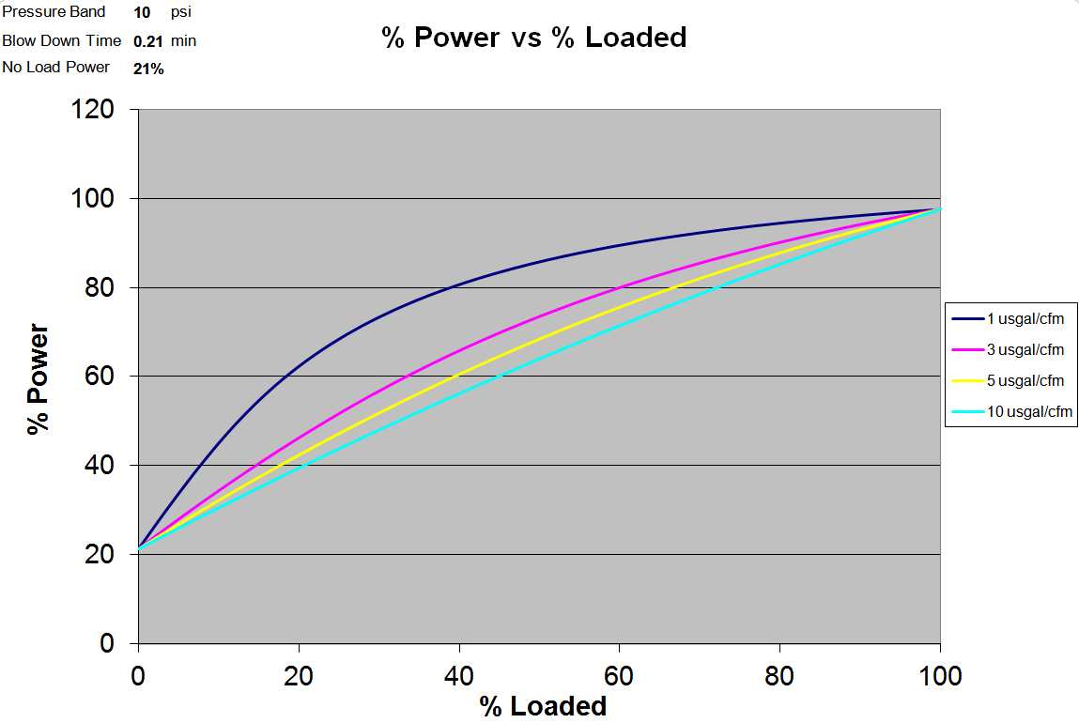  Figure 12: Reducing system pressure can work out as an air flow reduction.  Power change  Flow change
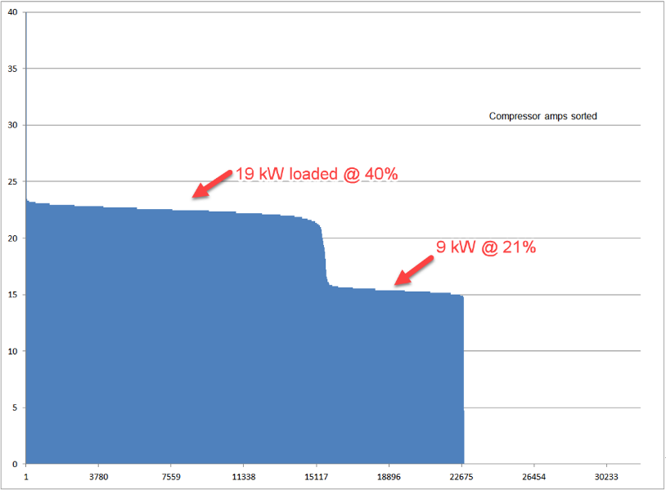
Example calculation:
Figure 13: Plot of compressor amps illustrating time loaded, unloaded, and off.
A 100 psi load/unload compressor has its discharge pressure reduced by 15 psi
- The unloaded kW is unchanged.
- 1% power reduction for every 2 psi pressure reduction when loaded.
- Power reduction = 15%/2 = 7.5%
- 19 kW x .075 = 1.43 kW
- The average power is reduced by 1.43 kW x 0.4 = 0.57 kW
- Flow reduction ignored in this case.

More Efficient Compressor
Savings mechanisms: Efficiency of air production is improved.  Calculation method: Find the baseline flow (average flow or full flow range) to determine the % capacity of new compressor. Using CAGI sheet and compressor curve to determine % power and full load power of the new compressor. Multiply to get power estimate and subtract form baseline to estimate savings.  Calculation pitfalls: Adjust for discharge pressure, factor the slope/intercept of the characteristic curve, some control methods are non-linear. | 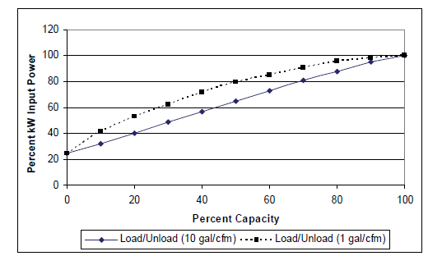  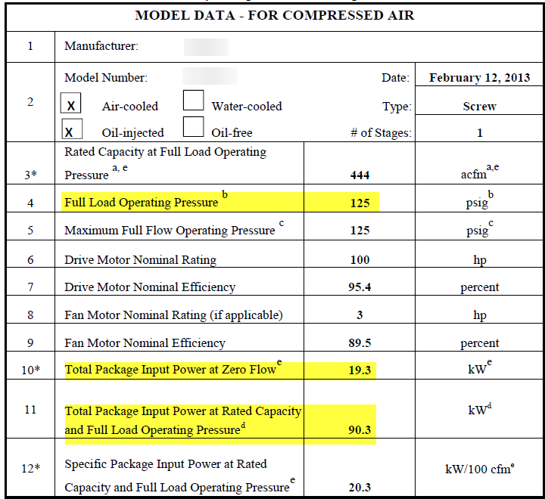  Figure 14: Compressor characteristic curve for a typical load/unload compressor.
Example calculation:
Figure 15: Typical CAGI sheet with key parameters highlighted.
Baseline: 100 HP modulating compressor
- Average flow = 200 cfm; Peak flow = 400cfm
- Average Power = 80 kW; or 40kW/100cfm
New 100 HP load/unload compressor with 2,000 gals
- Rated pressure = 125 psi, Discharge pressure = 110 psi
- Full load power = 90.3 kW @ 125 psi, adjust for lower pressure
- (125-110)/125 = 12% pressure reduction → 6% power reduction
- New full load power = 90.3 * 0.94 = 84.9 kW
- % Loaded = 444/200 = 45% → % Power ~ 61%
- New power ~ 52 kW
- Average savings = 80 – 52 = 28 kW
- 28 kW x 8760 hours = 245,280 kWh/year

Questions and Answers

Notes:
_____________________________________________________________________
_____________________________________________________________________
_____________________________________________________________________
_____________________________________________________________________
_____________________________________________________________________
_____________________________________________________________________
_____________________________________________________________________
_____________________________________________________________________
_____________________________________________________________________

