Establishing targets that drive action
Participant Workbook


This workshop is hosted via MS Teams.

Many organizations are setting longer term energy and GHG emission reduction targets, but without a clear vision and understanding of what’s required to follow through with that vision, energy management efforts flounder and organizations fall short of their energy goals.
This workshop provides a strategy to set targets that drive action using the objectives and key results (OKR) framework that establish measurable objectives along with key results that must be achieved for the objectives to be met. This process provides an actionable framework that illustrates what is required in all areas of an organization to ensure success. The lesson includes strategies to engage leadership and guide the development of OKRs.
Group coaching sessions will be offered following the launch of the workshop to support the implementation of OKRs in organizations.

In this workshop, Participants will:
- Learn a framework for achieving energy goals
- Apply the framework within their own organization
- Identify key results in service of their goals

Common pitfalls when setting targets
Failure happens when targets:
- Are not SMART
- Lack focus on what needs to happen
- Lack alignment on how to achieve the given goal
- Lack clarity around accountability
Not only does the target need to be clear, but there should also be clarity around what needs to happen to achieve it.

SMART Targets
SMART targets help provide some clarity. SMART targets are:
- Specific: Targeting a particular area for improvement
- Measurable: Criteria to measure your progress toward the accomplishment of the goal
- Achievable: Can be ambitious, but not impossible to achieve
- Relevant: Goal meaningfully contributes to the larger objectives of the organization
- Time-bound: Contains a specific target date to achieve the objective
While SMART targets can be a big improvement, there are still some shortcomings to this approach.

Objectives and Key Results
The OKR framework can be used by individuals, teams and organizations. It has contributed to the success of Google, LinkedIn, Microsoft and others.
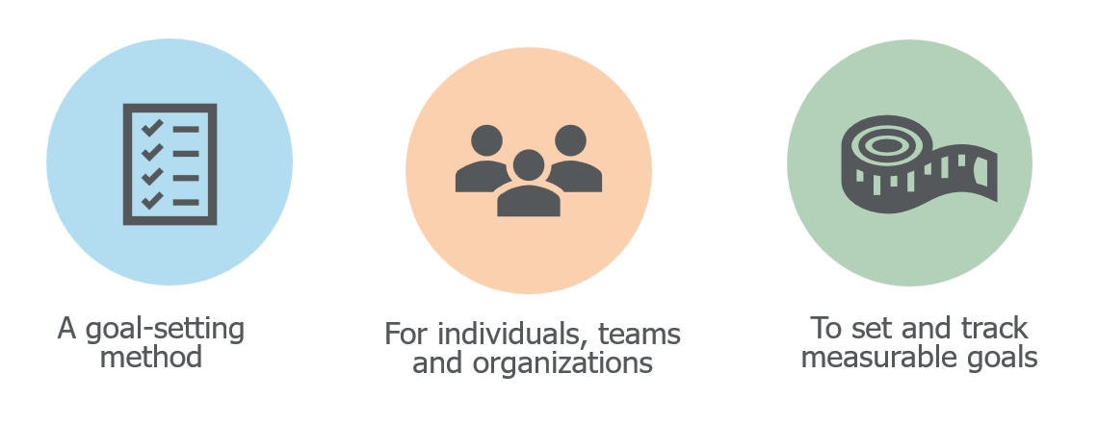
The ODR framework involves both setting and tracking measurable goals that are supported by key results.
This is the important part because the key results are established as a causal relationship with the given objective. If you want to achieve that objective, you need to achieve the key results, and
the key results must be realized to achieve the objective.

Objective: The what

A clear goal that provides direction and inspiration
Example: Expand Netflix’s global reach

Key results: the how
Things that must happen to achieve the objective
Example:
- Lauch Netflix services in five new countries
- Achieve 10 million new international subscribers
- Increase content production in local languages by 25%

Five key benefits of a target-setting framework
Focus | Setting a limited number of objectives and key results ensures people focus on the things that are important.
Alignment | As you shift to planning and executing your plan, managers and contributors can connect their day-to-day activities to a cohesive purpose.
Commitment | Involving team members in the goal-setting process and seeing how their actions contribute to larger actions lead to higher engagement and motivation.
Accountability | When what needs to happen is clear, it is easier to hold people accountable and for them to hold themselves accountable as you track progress toward the objective.
Adaptability | Clearly laying out what needs to happen provides transparency, which makes it easy to adjust objectives and key results, if required, due to changing circumstances.

Reminder: Tips for Writing effective key results
- Start with the end in mind:
  - Make sure your key results have a causal relationship with your objective
  - Achieving your objective is dependent on achieving the key results
- Make it measurable:
  - Make sure achievement of the key results can be objectively demonstrated without room for interpretation
  - The key results should be quantifiable and verifiable
- Make it manageable:
  - Make sure that progress toward the key results can be tracked and reported on a regular basis
  - Key results should be specific enough that managers and others can develop action plans to achieve them in a manner that is aligned with the overall objective
And do not forget to keep it simple!
While your key results should cover everything that needs to happen to achieve your objective, you should not have more than three to five key results to keep people focused on what is most important.

Breakout Room: Case Study

instructions
- Read the case study below
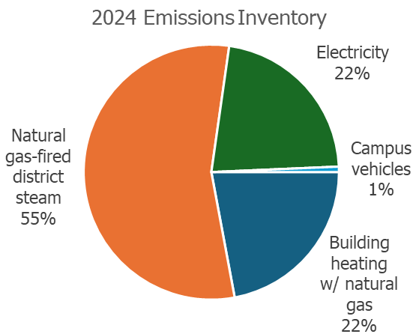
- As a group, identify three key results to support the objective

Case Study Information
An Ontario university has the following objective:
Reduce energy-based GHG emissions by 60% from 2024 levels by 2025.
They need to set key results that will help them achieve this objective. The pie chat to the right illustrates their 2024 emissions inventory by percentage.

Current energy use and GHG emissions
2024 GHG inventory | Natural gas-fired district steam: 55%  Natural gas space heating: 22%  Electricity: 22%  Fuel for campus vehicles: 1%
Average energy use intensity (EUI) | 2.5 GJ/m2  Note: This is 15% higher than the average EUI for Ontario universities and 25% higher than the lowest Ontario university EUIs.
Capital planning | Plans to add two new large buildings between 2024 and 2050.  Plans for major renovations and upgrades to four existing buildings between 2024 and 2050.

What key results would best support achieving their objective?
1)

2)

3)

The importance of information, collaboration and consensus
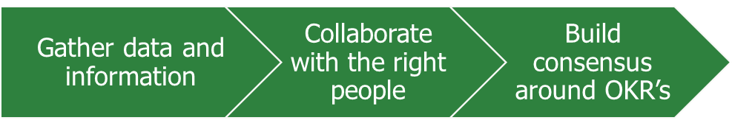
- Objectives and targets need to be set based on the data and information gathered. Plan for what you need to investigate to make sure you have a solid understanding what needs to happen to move from your current situation to your desired future state. If people start pushing back that a necessary action might be challenging, you will want some evidence to justify including it.

- You cannot set objectives and key results in isolation. It is important to bring the right people in early to make sure they are committed to the key results and that you are not missing key information that would lead to negative impacts on the effectiveness of key results.

- You will need to build consensus around the objective and key results to make sure everyone is aligned. This includes not only key decision makers, but also managers and others who will be involved in developing and executing the action plans to achieve the key results.

Breakout Room: Setting Targets for your Organization

instructions:
- Discuss your organization’s objective and key results that would lead to success.
- Discuss what information you need to be confident that the key results will support success.
- Discuss who should be involved in deciding which key results to include.

Objective

Potential Key Results

Information needed to Develop Key Results

People to Involve in deciding which key results to include

tips for getting started
- Host a strategic alignment session with key people:
  - Bring together people who will be able to support the development of the objective and key results
  - Ensure they understand the value of developing objectives and key results
  - Work together to identify what information is needed to inform which key results are required
- Create a clear timeline of activities:
  - Identify when key results should be finalized to develop a work back plan
  - Develop a plan to get the information and data you need
  - Schedule times to collaborate with key people to develop a consensus around key results
- Consider where you want to take a bottom-up versus a top-down approach for setting OKRs:
  - A top-down approach involves setting the objective, defining key results, and then pushing those key results down to teams to develop action plans to achieve them
  - Some organizations might prefer a bottom-up approach whereby teams are tasked with coming up with their own objectives and key results as long as they are aligned with the organization’s priorities
- Plan a communication strategy for before, during and after the process:
  - Getting the full benefits of focus, alignment and commitment requires a strong communication strategy to keep people informed and aligned
  - People throughout the organization should be engaged to make sure they understand why these objectives and key results are important, how they will impact them, and how achieving the results will benefit them
  - Consider taking a change management approach
Action | Timeframe
e.g. Review current energy-related objectives/targets and assess if key results are good enough to achieve them.

More Resources
- OKR Institute:
  - 60+ resources that will make you an OKR champion
  - OKR examples in the energy industry
  - Become a certified OKR expert
- Perdoo: The ultimate guide to OKR
- Munich Business School: Smart goals simply explained

