Energy Management as a Framework to Achieve GreenHouse Gas Reductions

(and other sustainability goals)
Participant Workbook
As organizations are establishing greenhouse-gas (GHG) reduction and long-term sustainability goals, there is often a gap between where they want to go and knowing how to get there. Energy management best practices are best achieved by following strategic energy management principles. Codified in ISO 50001, a a strategic energy management system provides a framework to strengthen commitment, plan for success, use data to measure and inform progress, and align efforts across your organization to help achieve a wide range of sustainability goals.
This workshop will explore how an energy management framework can be adapted to support your GHG reduction and other sustainability goals.

In this workshop, participants will:
- Understand how the energy management framework can support achievement of both GHG reduction and other sustainability goals.
- Connect examples of key success factors from decarbonization efforts to components of energy management.
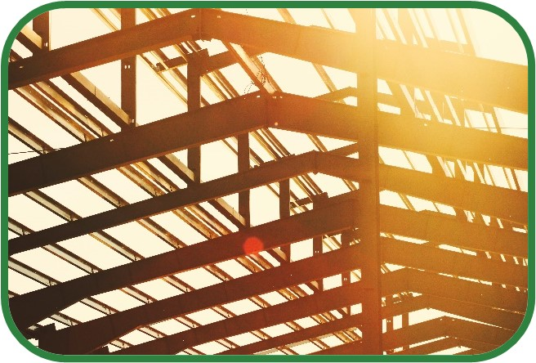
- Develop a strategy to adapt the energy management framework to support your sustainability goals.
This workshop will be hosted over Microsoft Teams.
For support using Teams, see the last page of this workbook.

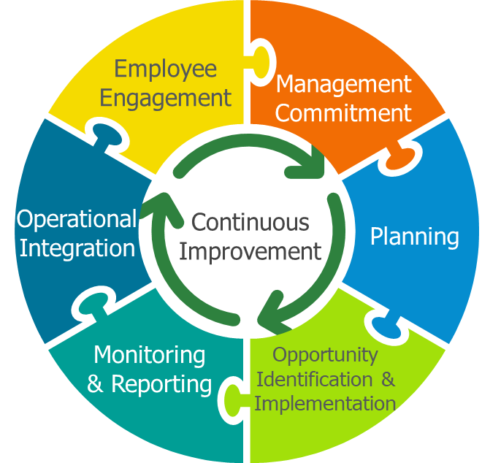
Components of an Energy Management Framework
The energy management framework supports the achievement and persistence of energy performance improvements by integrating energy management considerations throughout an organization.

There are seven key components to the framework:
- Management Commitment includes establishing goals, accountability and resources required to achieve success, including the formation of an energy team.
- Planning involves understanding your starting point and developing actionable plans to achieve objectives.
- Opportunity Identification & Implementation means developing processes to consistently identify and implement improvements.
- Monitoring & Reporting involves using data to drive action and monitor progress.
- Operational Integration ensures that everyone understands how their roles contribute to achieving the goals and acts accordingly.
- Employee Engagement includes making all staff aware and active participants in driving progress towards goals.
- Continuous Improvement means continually evaluating performance and improving the suitability, adequacy and effectiveness of the energy management system and progress towards goals.

Examples of Decarbonization Success Factors

New York University Passive House Retrofit
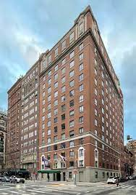
Retrofit of 100-year-old building to Passive House Standard to be completed in 2024, resulting in 100% reduction in fossil fuels and 3.5% reduction in30-year total cost of ownership.
Key success factors:
- Commitment to third-party building standards.
- Starting early with a feasibility study far in advance of construction.
- Assessing costs based on Total Cost of Ownership.
For more information:
- Urban Passive House Episode 3: Rubin Hall Retrofit (webinar)
- NYU to Retrofit Historic Rubin Hall

Industrial Pathway to Decarbonization
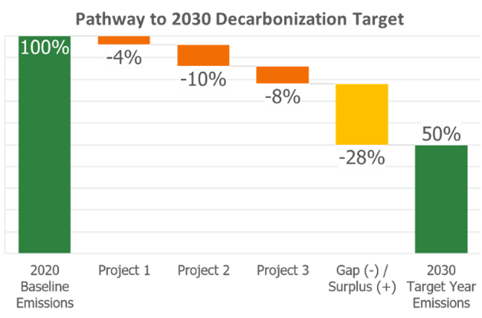
Developing an achievable plan for 50% GHG emission reduction target.
Key success factors:
- Laid out planned and identified projects to see how big a gap there was between current path and targets.
- Benchmarked facilities to learn from high performers.
- Conducted studies and pilots to fill the gap.

CLF Office Electrification
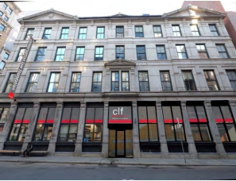
Large office building renovation included electrification of space heating and hot water.
Key success factors:
- Aligned renovations with end-of-life replacement of major systems and deferred building maintenance.
- Staff engagement pushed for decarbonization and improved comfort.
- Treatment of asset depreciation as an operating expense.
For more information:
- Thermal Electrification of Large Buildings (page 31)

Non-energy Sustainability Goals within your Organization
From the list below, highlight or select the non-energy sustainability goals that your organization currently has:

- Greenhouse Gases
- Water Consumption
- Wastewater
- Solid Waste
- Criteria Air Contaminants
- Hazardous Materials
- Resource Conservation
- Other: ____________________

Applying an Energy Management Framework to those goals
While an energy management framework represents good practices that can support other sustainability goals, the components of the framework may need special considerations to:
- Accommodate different sustainability goals, and
- Ensure those goals do not end up competing with energy or each other for resources or priority status.

Which of the non-energy sustainability goals do you want to explore how to effectively apply an energy management framework to support?

Adapting Framework Components to Support Other Sustainability Goals
Fill out the table below with tips on how to apply an energy management framework to you non-energy sustainability goals.
Framework Component | What does this component look like for different goals? | How to avoid competition between goals?
Management Commitment
Planning
Opportunity Identification & Implementation
Monitoring & Reporting
Operational Integration
Employee Engagement
Continuous Improvement

Teams Instructions

Joining the Workshop
If you are not familiar with Teams, please see the following links for instructions on how to join. You can also join a test meeting by following these instructions to familiarize yourself with using Teams.
- How to join a Teams meeting (app or web)
- How to join a Teams meeting in Microsoft Teams (free version)
- How to join a Teams meeting without a Microsoft Teams account
- How to join a Teams meeting by phone

If you are having trouble connecting, please see the following resources on troubleshooting when you can’t join a Teams meeting.

TEAMs Features Used in this Workshop
Raise your hand  - At the top of your screen, click Raise.  - A hand should show up next to your name under Participants.  - To lower your hand, click Raise again.  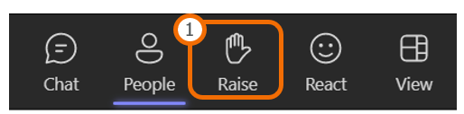  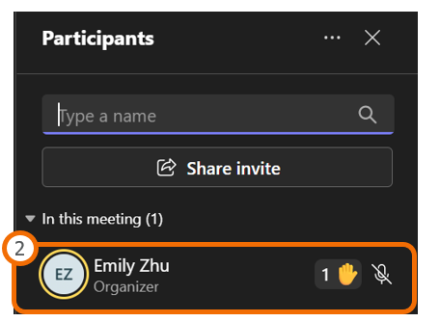 | use the chat to ask questions  - To use the chat, click Chat at the top of your screen.  - The chat should appear on the right side of your screen. Type your message in the message box.  